**Data Movement and Transformation**

**PROJECT OVERVIEW:**

In this project, we aim to implement a robust real-time data movement solution leveraging the capabilities of Azure Data Factory (ADF) and Azure Databricks. The primary objective is to ingest streaming data seamlessly through ADF and conduct near-real-time processing and analysis using Spark streaming in Azure Databricks.

**ABOUT THE PROJECT:**

This project is all about handling data in real-time, meaning we want to work with information as soon as it comes in, without any delays.

We're using two key tools from Microsoft's Azure cloud platform:

1. Azure Data Factory (ADF)
2. Azure Databricks
3. Azure Blob Storage

**i) Azure Data Factory(ADF)**: Azure Data Factory helps us bring in data from different sources, like devices or sensors, in a smooth and organised way.

**ii) Azure Databricks:** Once we have the data, we pass it over to Azure Databricks. Here, using a powerful tool called Spark Streaming, we can process and understand the data almost immediately. It's like getting answers in real-time rather than waiting. The processed data can then be stored or shown in a way that makes sense, maybe using tools like Azure Databricks for creating easy-to-read charts or graphs. The whole idea is to quickly make sense of the data as it flows in, helping businesses make faster and smarter decisions.

1. **Azure Blob Storage:** Azure Blob Storage is a cloud storage service provided by Microsoft Azure for storing large amounts of unstructured data, such as text or binary data. It is part of the Azure Storage service, which also includes services like Azure Files, Azure Queues, and Azure Tables.

**ARCHITECTURE DIAGRAM:**

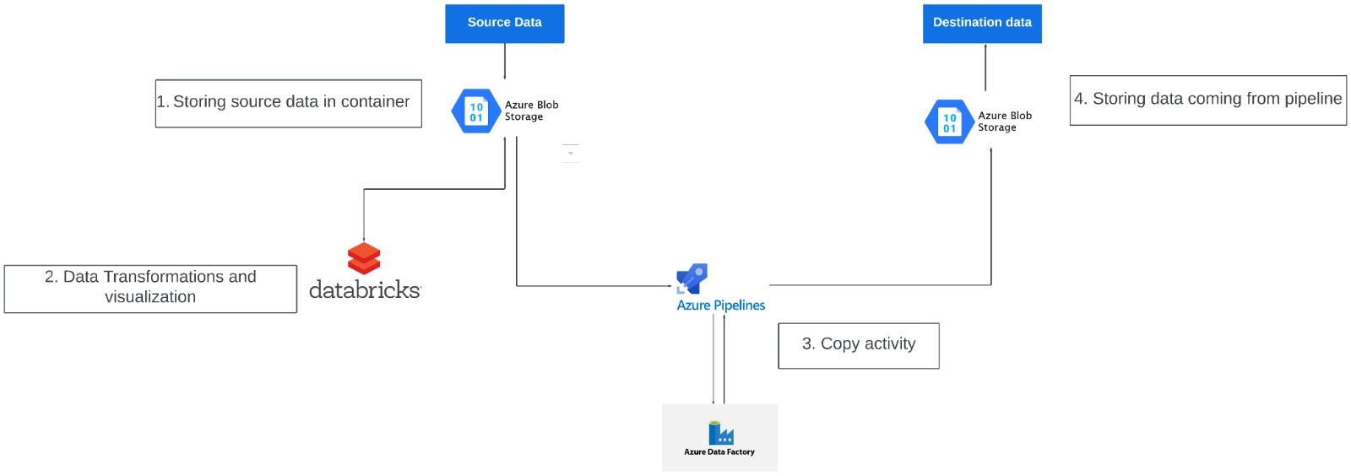

**HOW IT WORKS:**

**i)Data Ingestion with Data Factory:**

Create data ingestion pipelines in Azure Data Factory to ingest data from various sources into Azure Blob Storage Implement real-time data ingestion where applicable.

**ii)Transform data with Azure Databricks:**

Develop real-time analytics solutions using Azure Databricks to process data streams and derive insights. Implement data transformations, aggregations, and machine learning algorithms for analytics.

**AZURE RESOURCES USED FOR THIS PROJECT:**

**Azure Data Factory:** Orchestrates data pipelines for seamless movement and transformation across various sources, facilitating efficient data integration and management.

**Azure Databricks:** Provides an optimized Apache Spark environment for collaborative data analysis and machine learning tasks in the Azure cloud, streamlining big data processing workflows.

**Azure Storage Account (Blob Storage**): Offers scalable and reliable object storage for unstructured data, such as documents and images, with features like high availability and multiple storage tiers for cost optimization.

**Apache Spark (via Azure Databricks):** Empowers data processing and analytics tasks within Azure Databricks through its distributed computing capabilities, supporting multiple programming languages and enabling high-performance analytics at scale.

**PROJECT REQUIREMENTS:**

**Functional Requirements:**

**Azure Subscription Access:** The system must ensure access to an Azure subscription with the necessary permissions to create and manage resources.

**Data Source Configuration:** Identify and configure streaming data sources to be ingested using Azure Data Factory. This includes setting up connections, defining ingestion schedules, and ensuring data integrity during transfer.

**Databricks Workspace Setup:** Create a Databricks workspace and configure Spark clusters to enable real-time data processing. This involves defining cluster configurations, managing dependencies, and ensuring scalability and reliability for processing tasks.

**Storage Configuration:** Configure the Azure Storage Account to store both the ingested and processed data. This includes setting up appropriate containers, defining access controls, and implementing data retention policies.

**Non-Functional Requirements:**

**Security:** Ensure data security throughout the system by implementing appropriate access controls, encryption mechanisms, and compliance measures.

**Scalability:** Design the system to handle varying loads of streaming data efficiently, with the ability to scale resources up or down as needed to meet demand.

**Reliability:** Ensure high availability and fault tolerance of the system components to minimize downtime and data loss, leveraging features like redundancy and automated failover.

**Performance:** Optimize system performance for real-time data processing, including minimizing latency, maximizing throughput, and optimizing resource utilization.

**Cost Efficiency:** Optimize resource utilization and minimize unnecessary costs by implementing cost-effective storage solutions, efficient processing algorithms, and proactive cost monitoring mechanisms.

**OUTPUT/RESULT:**

**Azure Databricks and Spark Stream Visualization:**

**Step 1:** Set up an Azure Databricks workspace in the Azure portal.

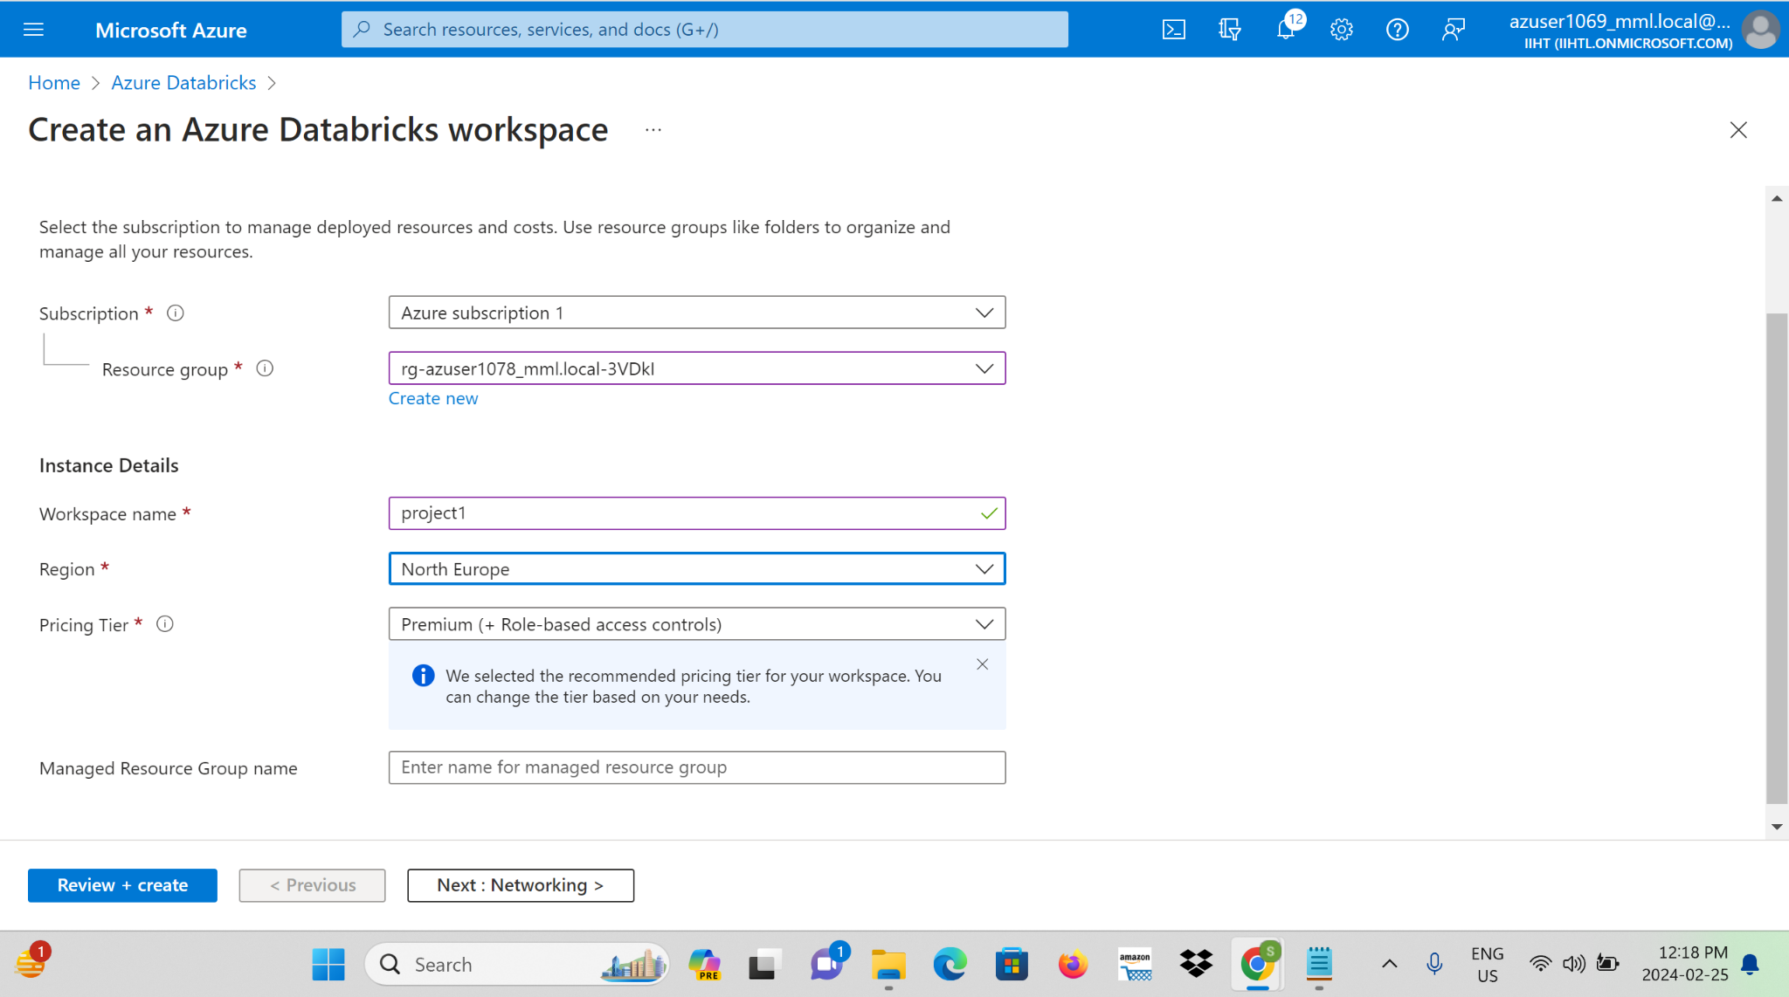

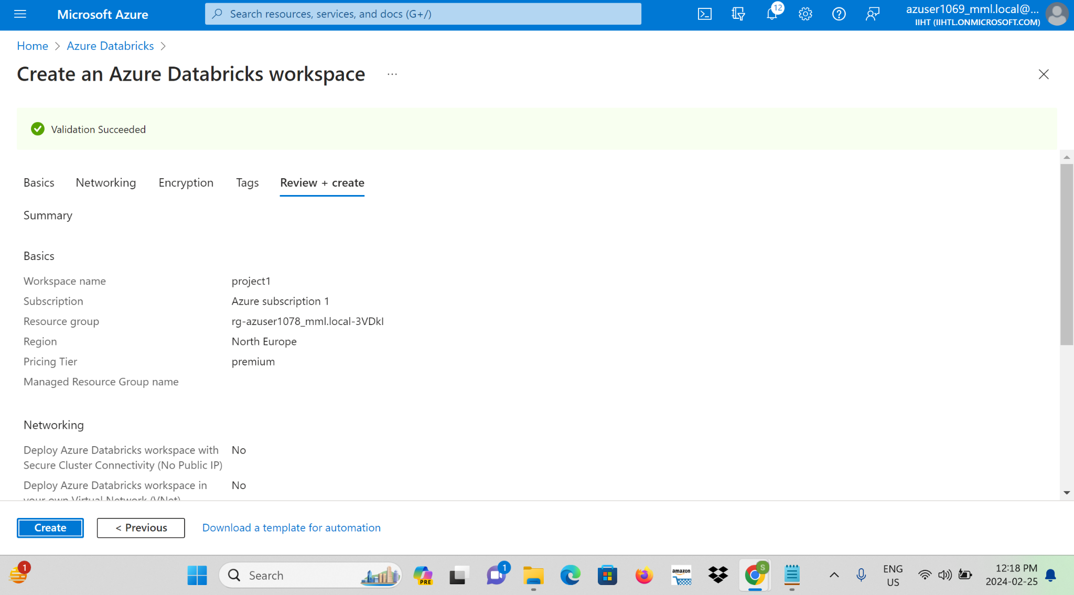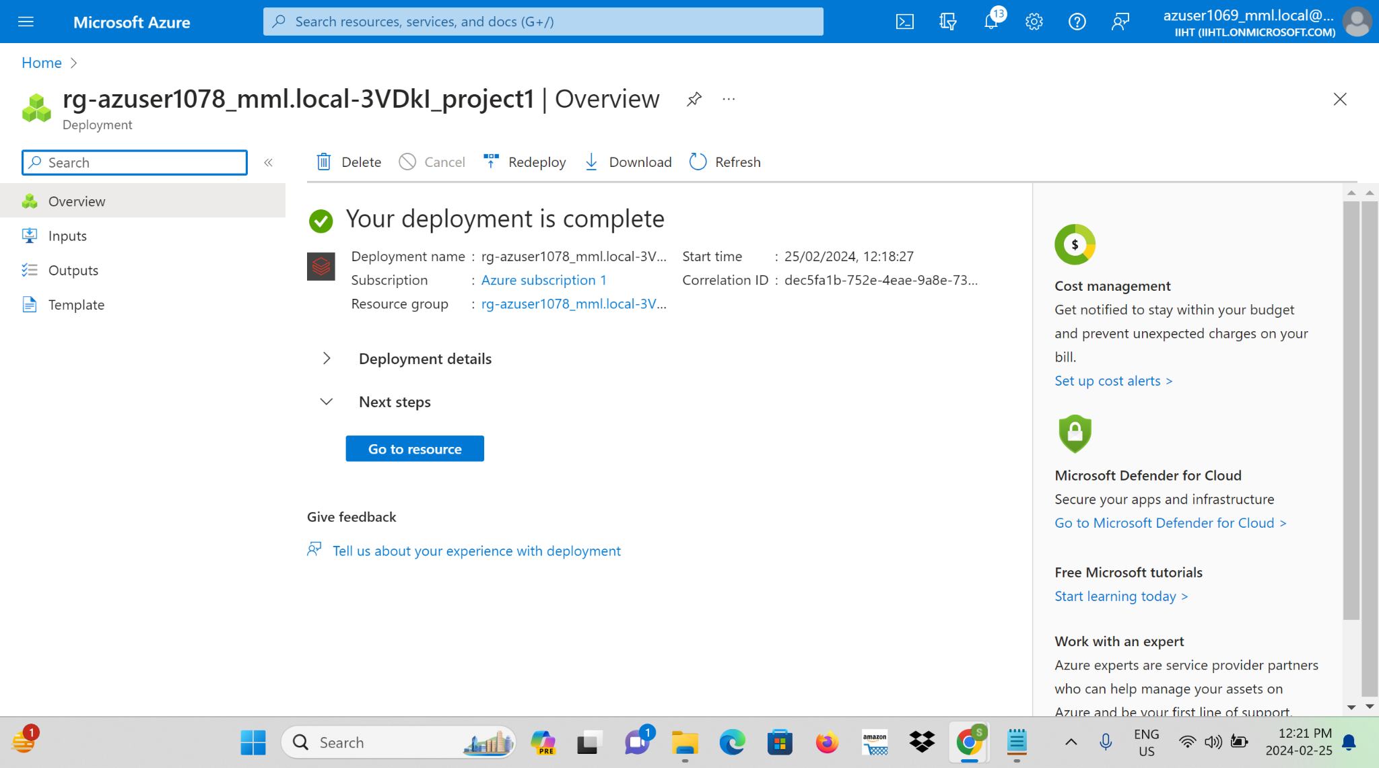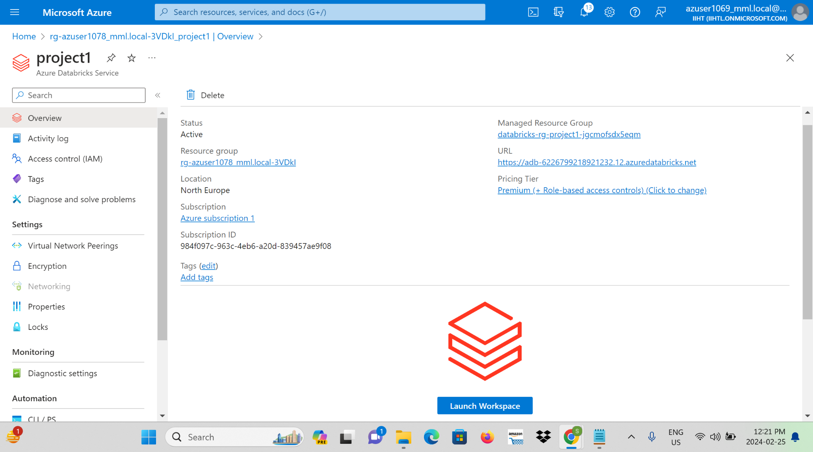

**Step 2:** Create a new Databricks cluster with the desired configuration.

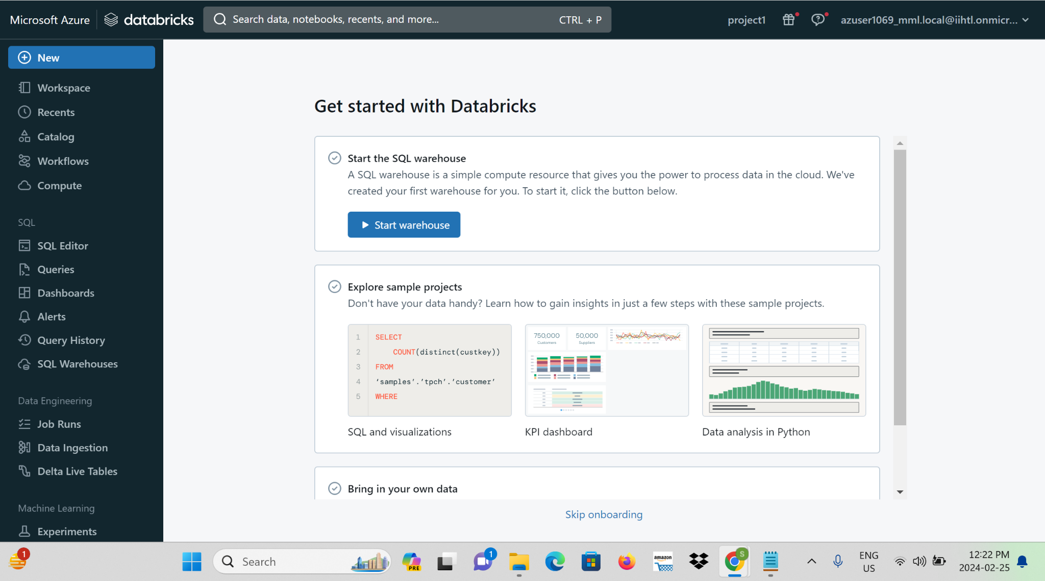

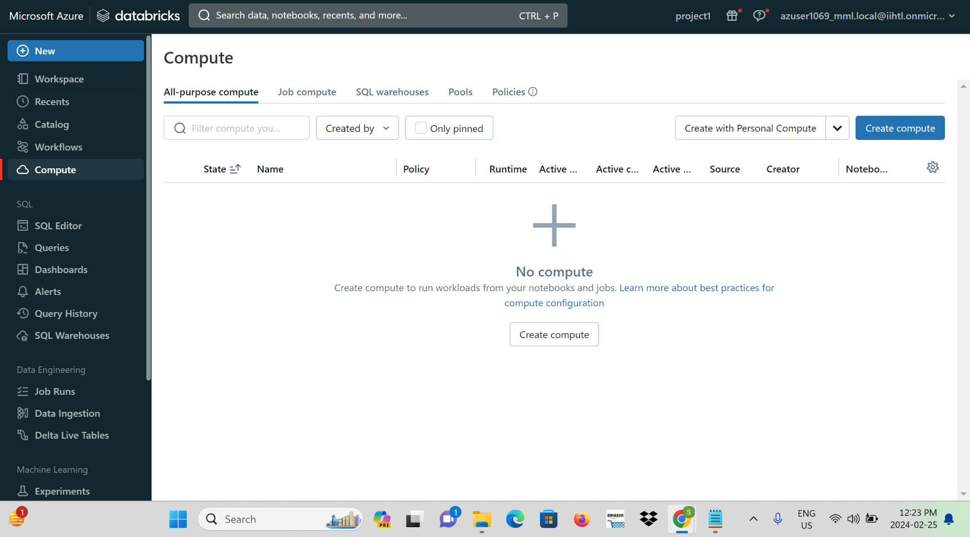

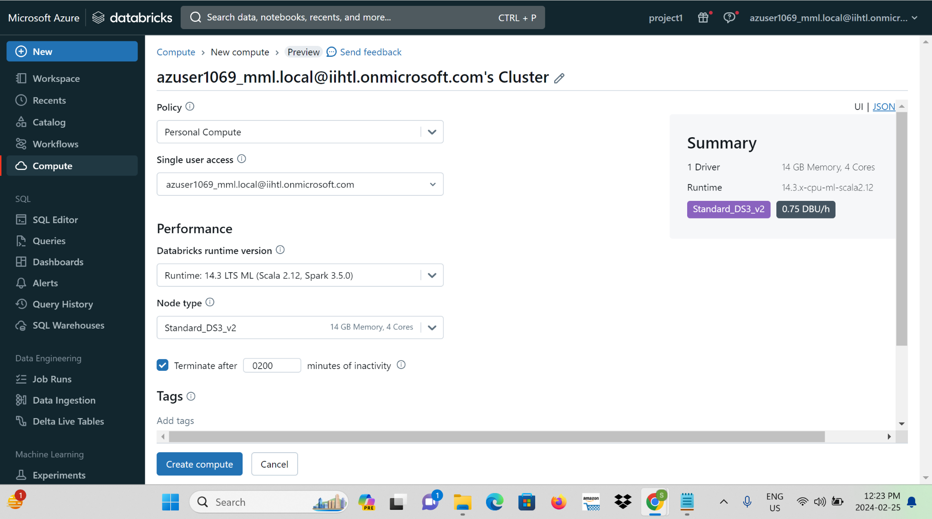

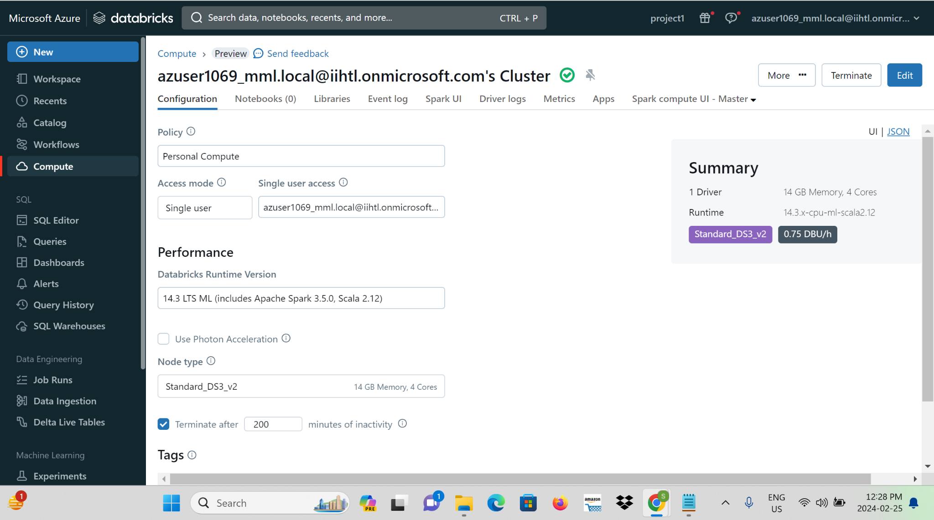

**Step 3:** Open the Databricks workspace and create a new notebook.

**Step 4:** Write and execute Spark streaming code in the notebook to process streaming data.

**i)Importing the data from storage account:**

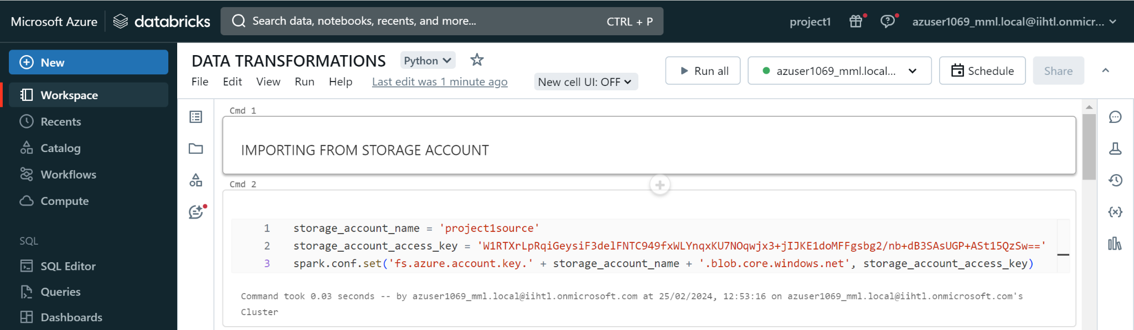

**ii)Giving path:**

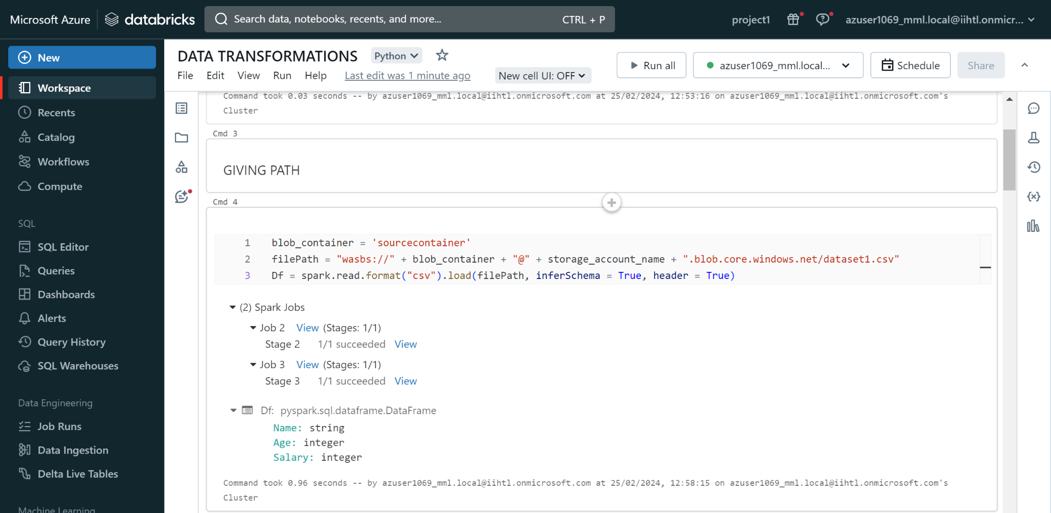

**iii)Importing Pyspark:**

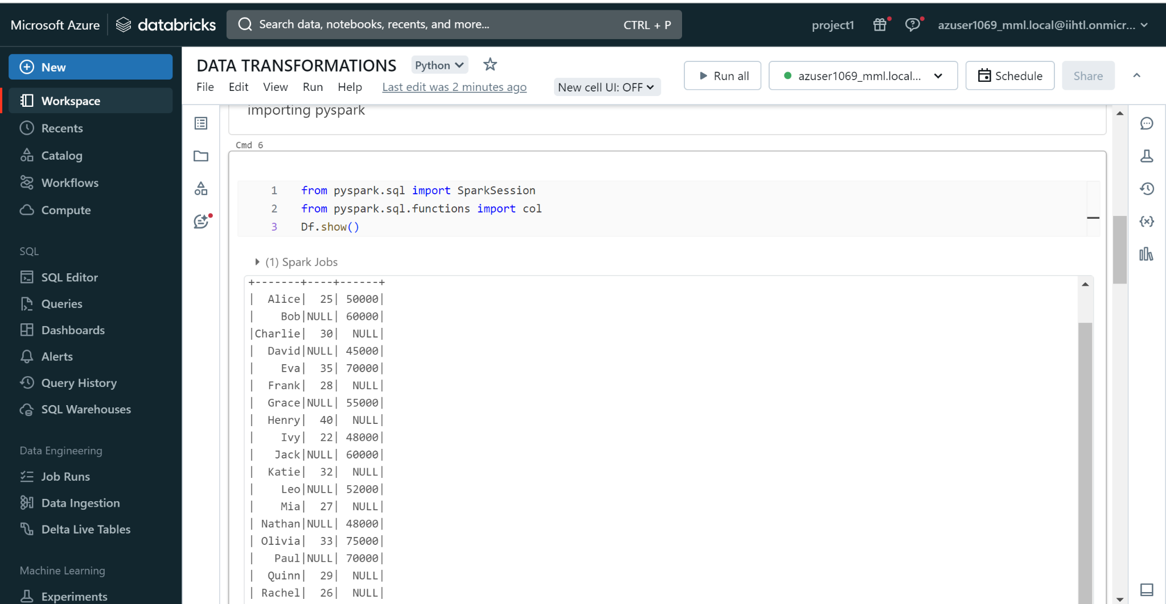

**iv)Describing the Dataframe:**

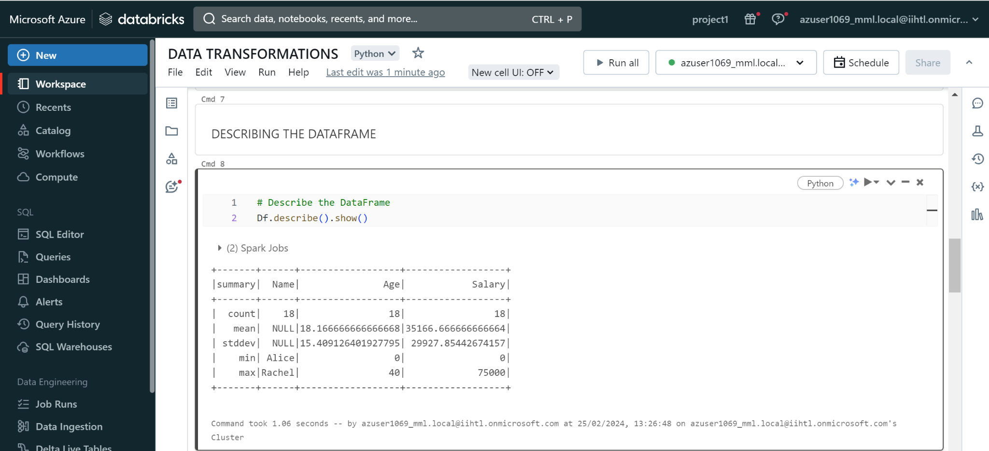

**v)Handling Null Values:**

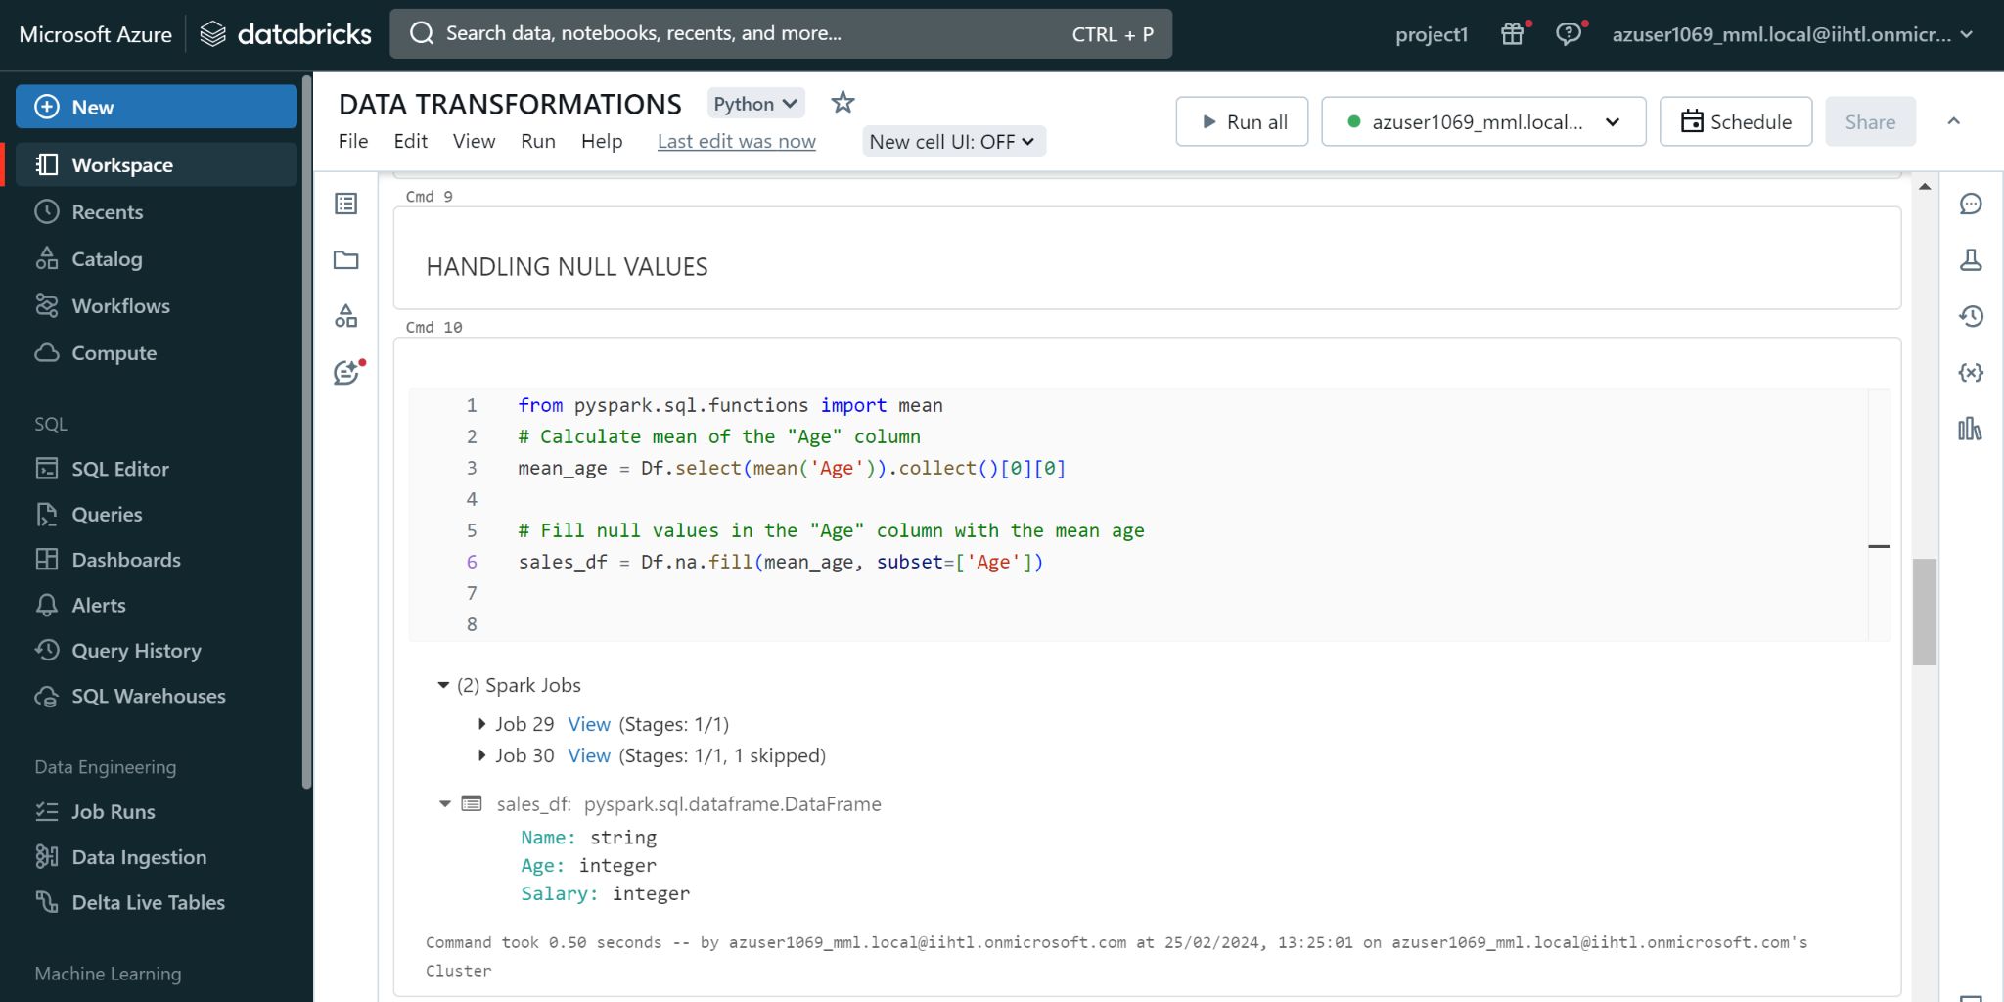

**vi)Performing Aggregate Functions:**

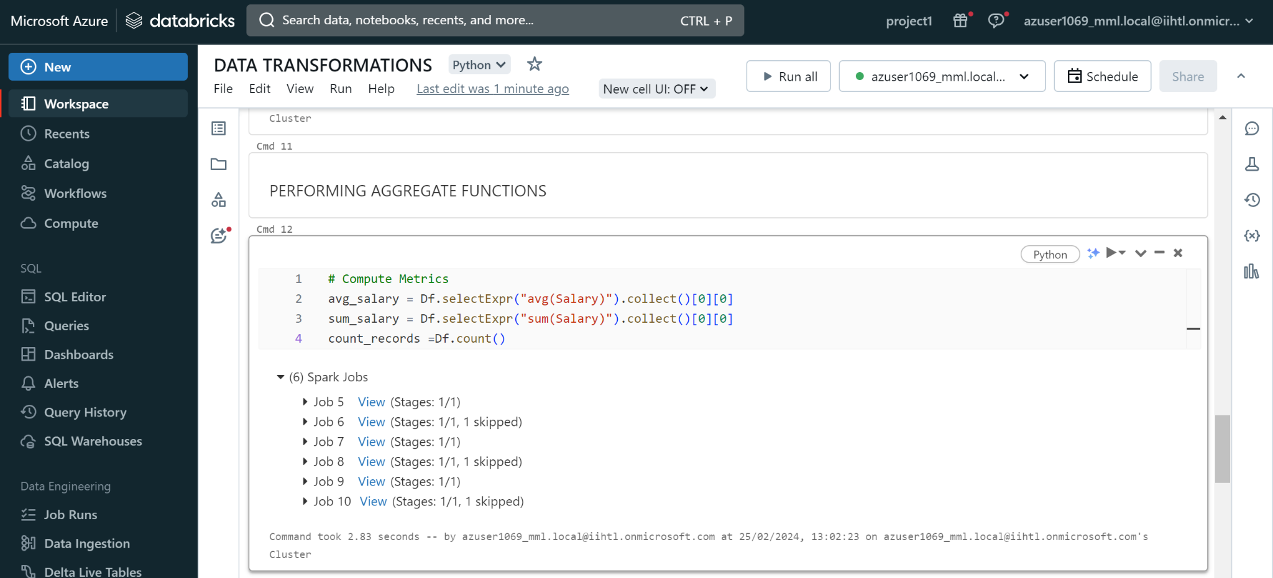

**vii)Displaying Average, Sum, Count Values:**

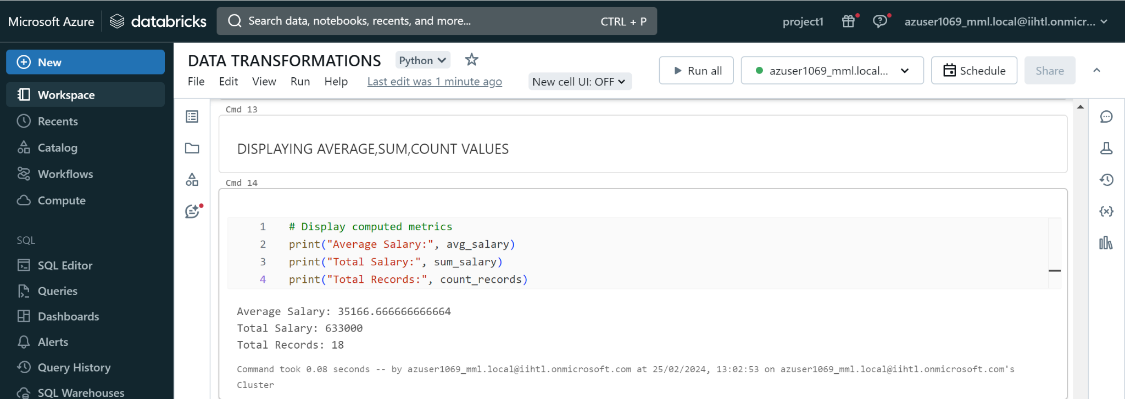

**Step 5:** Visualize and Data profile the streaming data using Databricks visualization spark.readStream

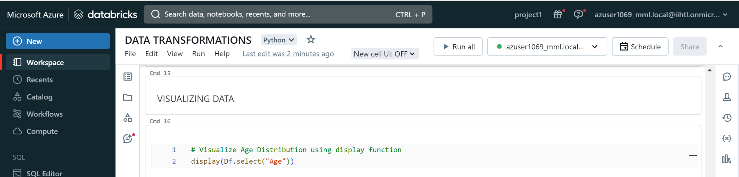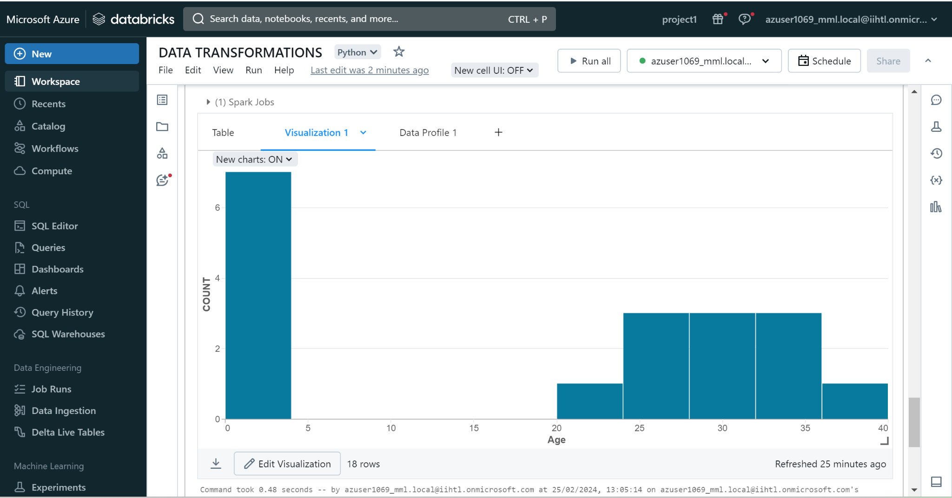

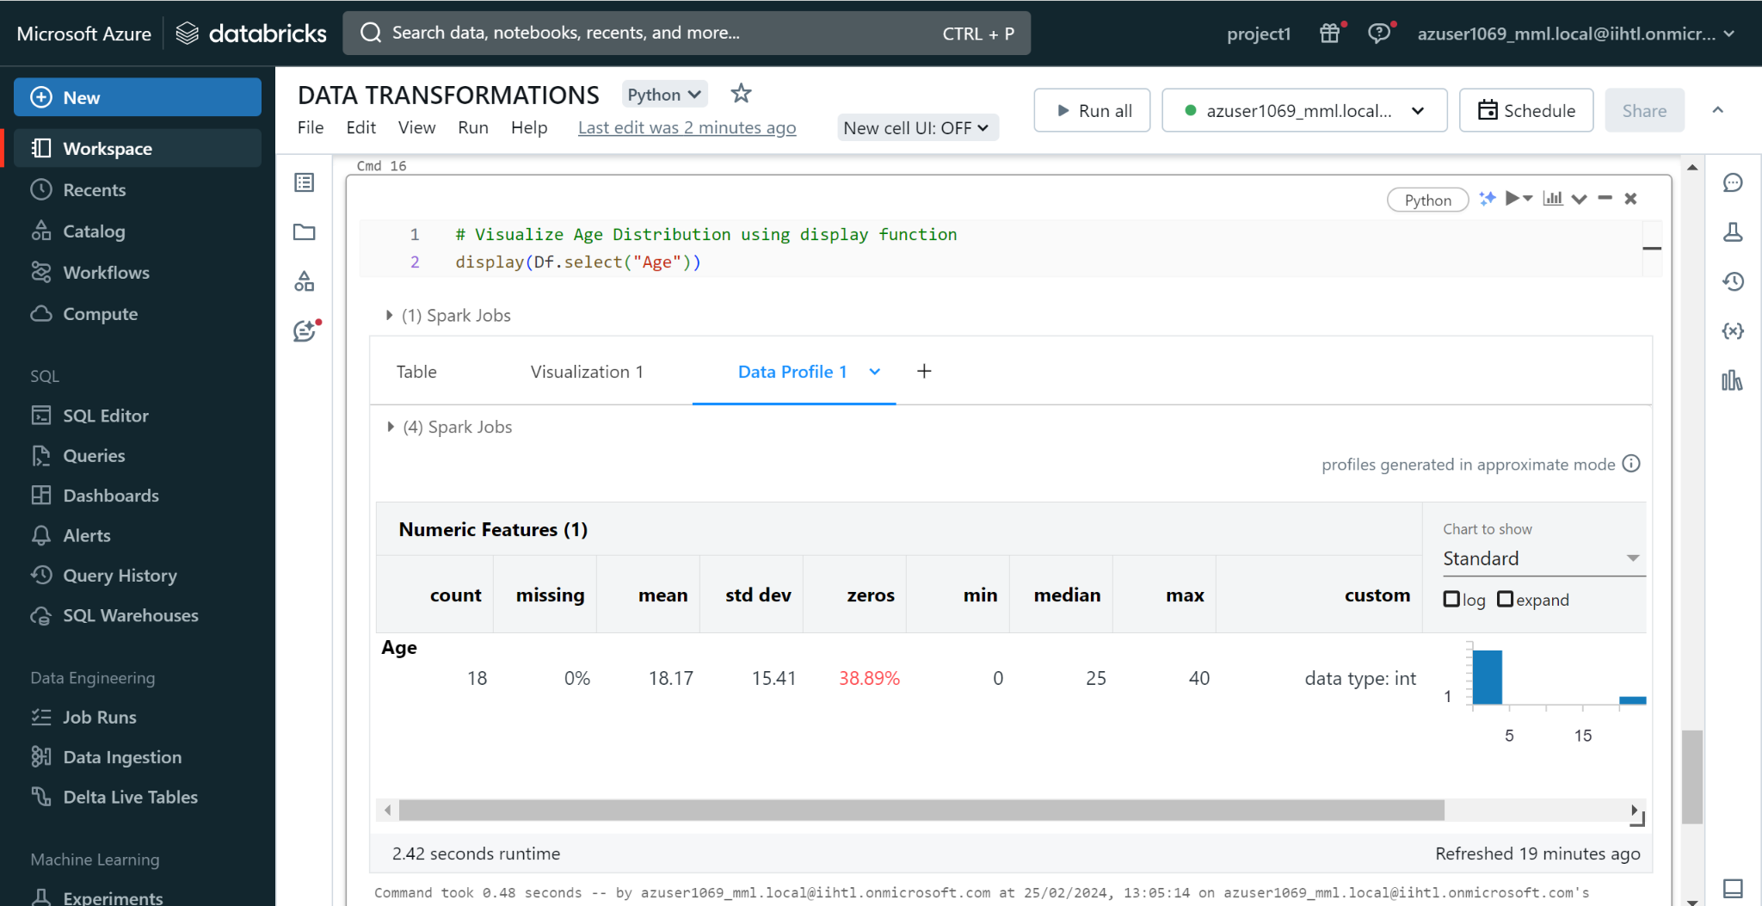

**Data ingestion with Data Factory:**Firstly to ingest the data we need to create a resource group and storage accounts.

**Step 1:**Navigate to the Azure portal and search for resource group and create a resource group.

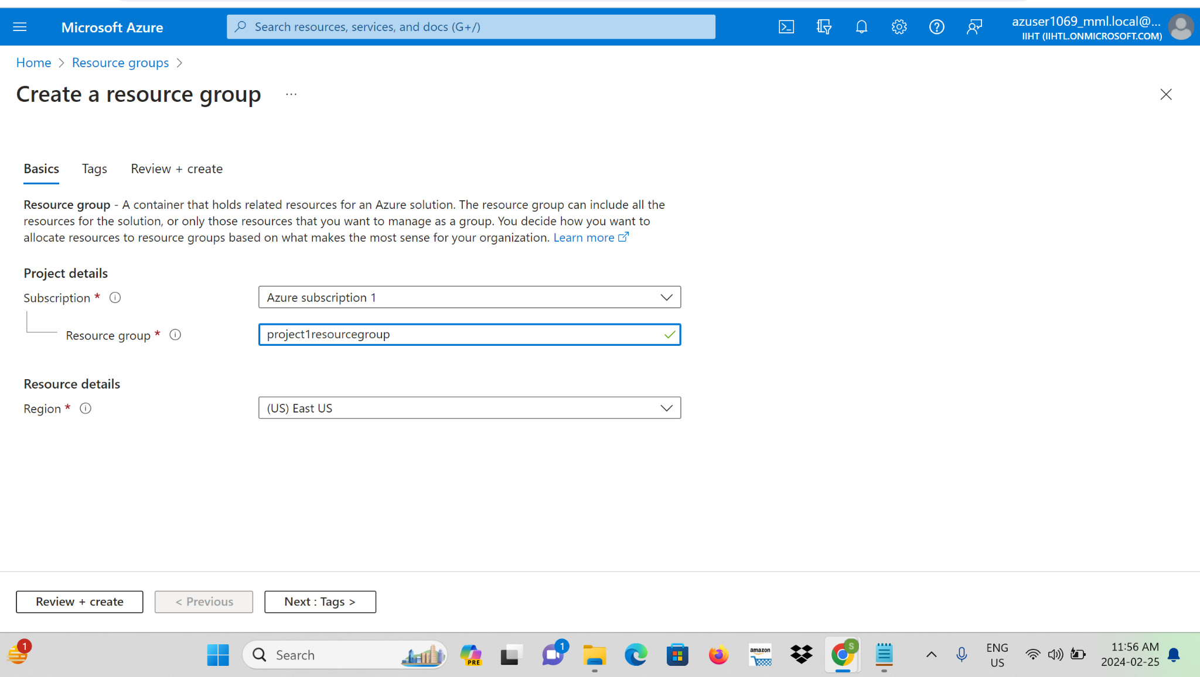

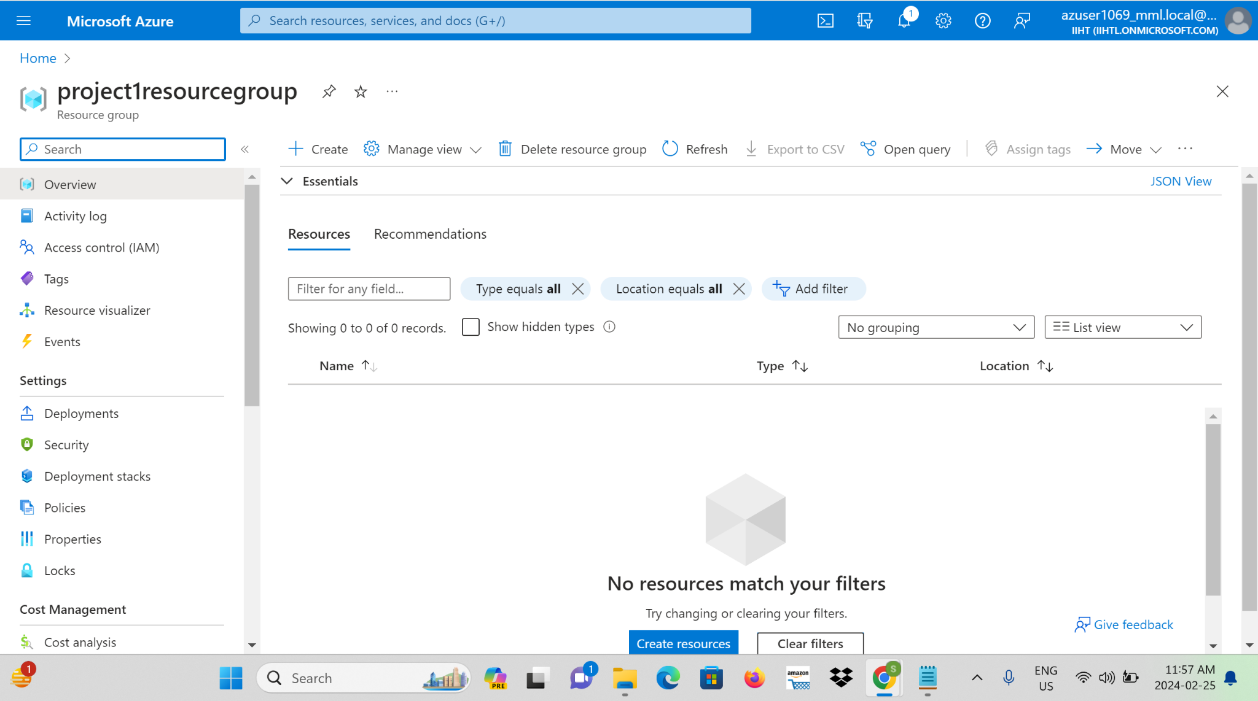

**Step 2**: Again search for the storage account and create a source storage account.

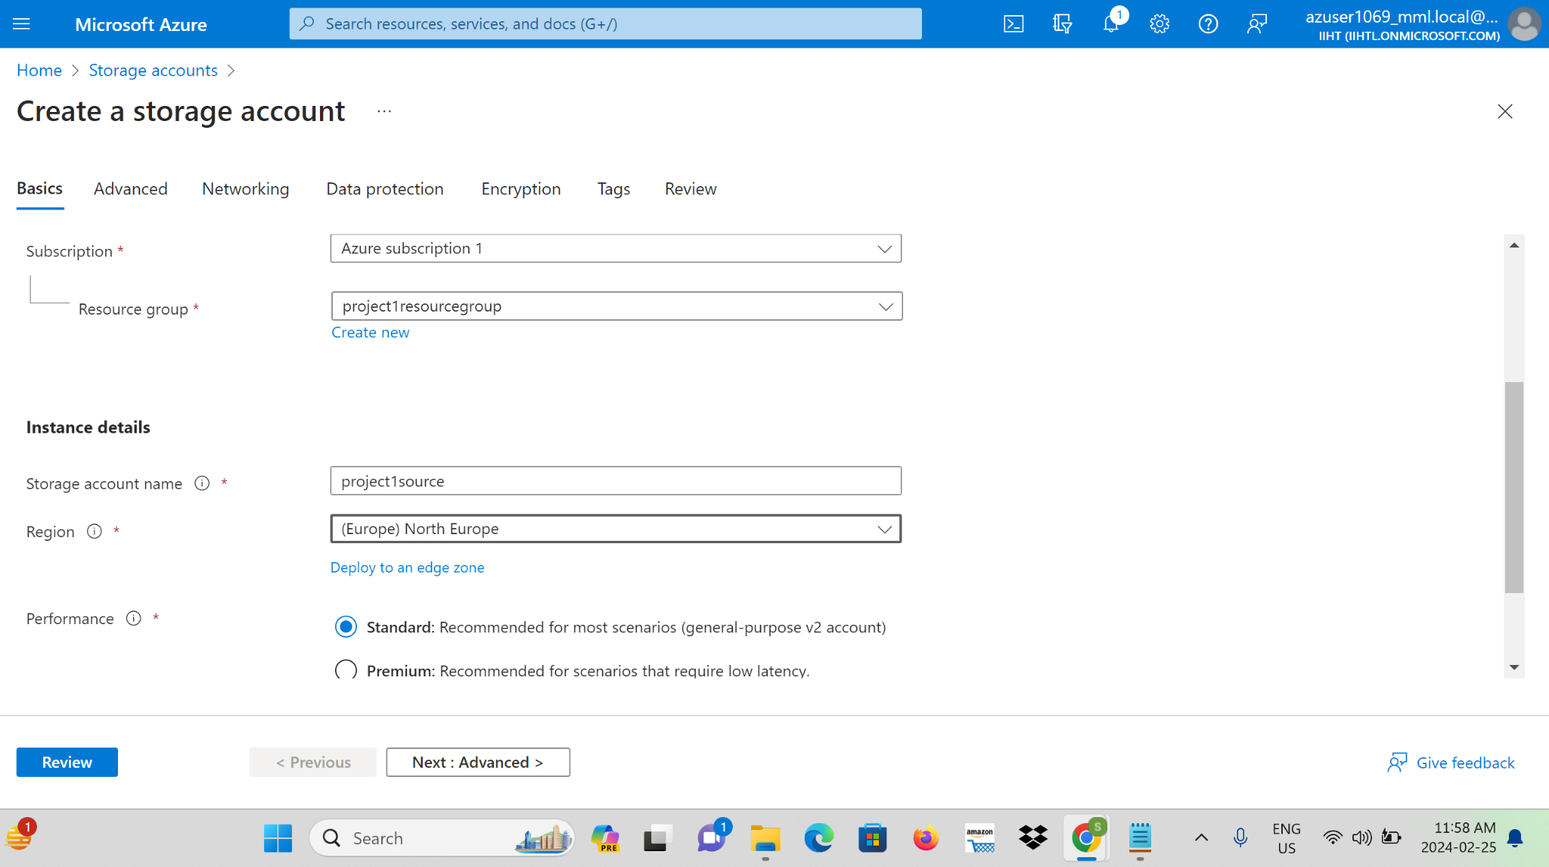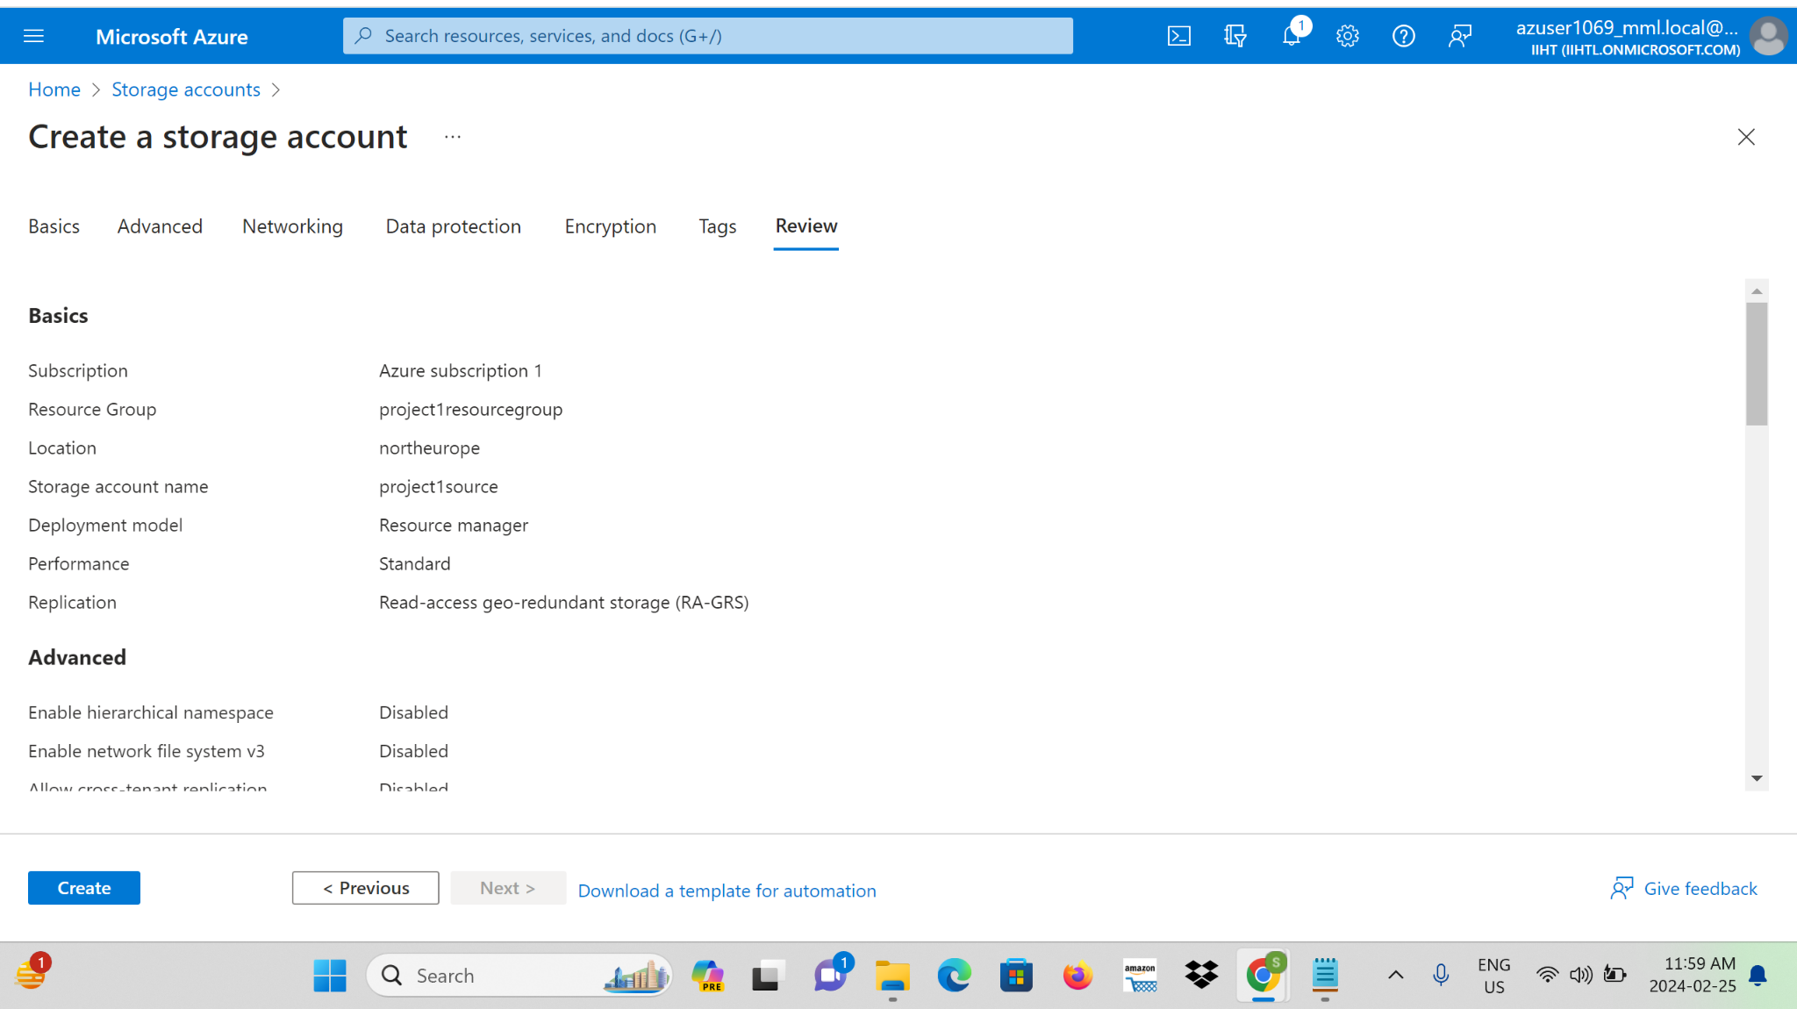

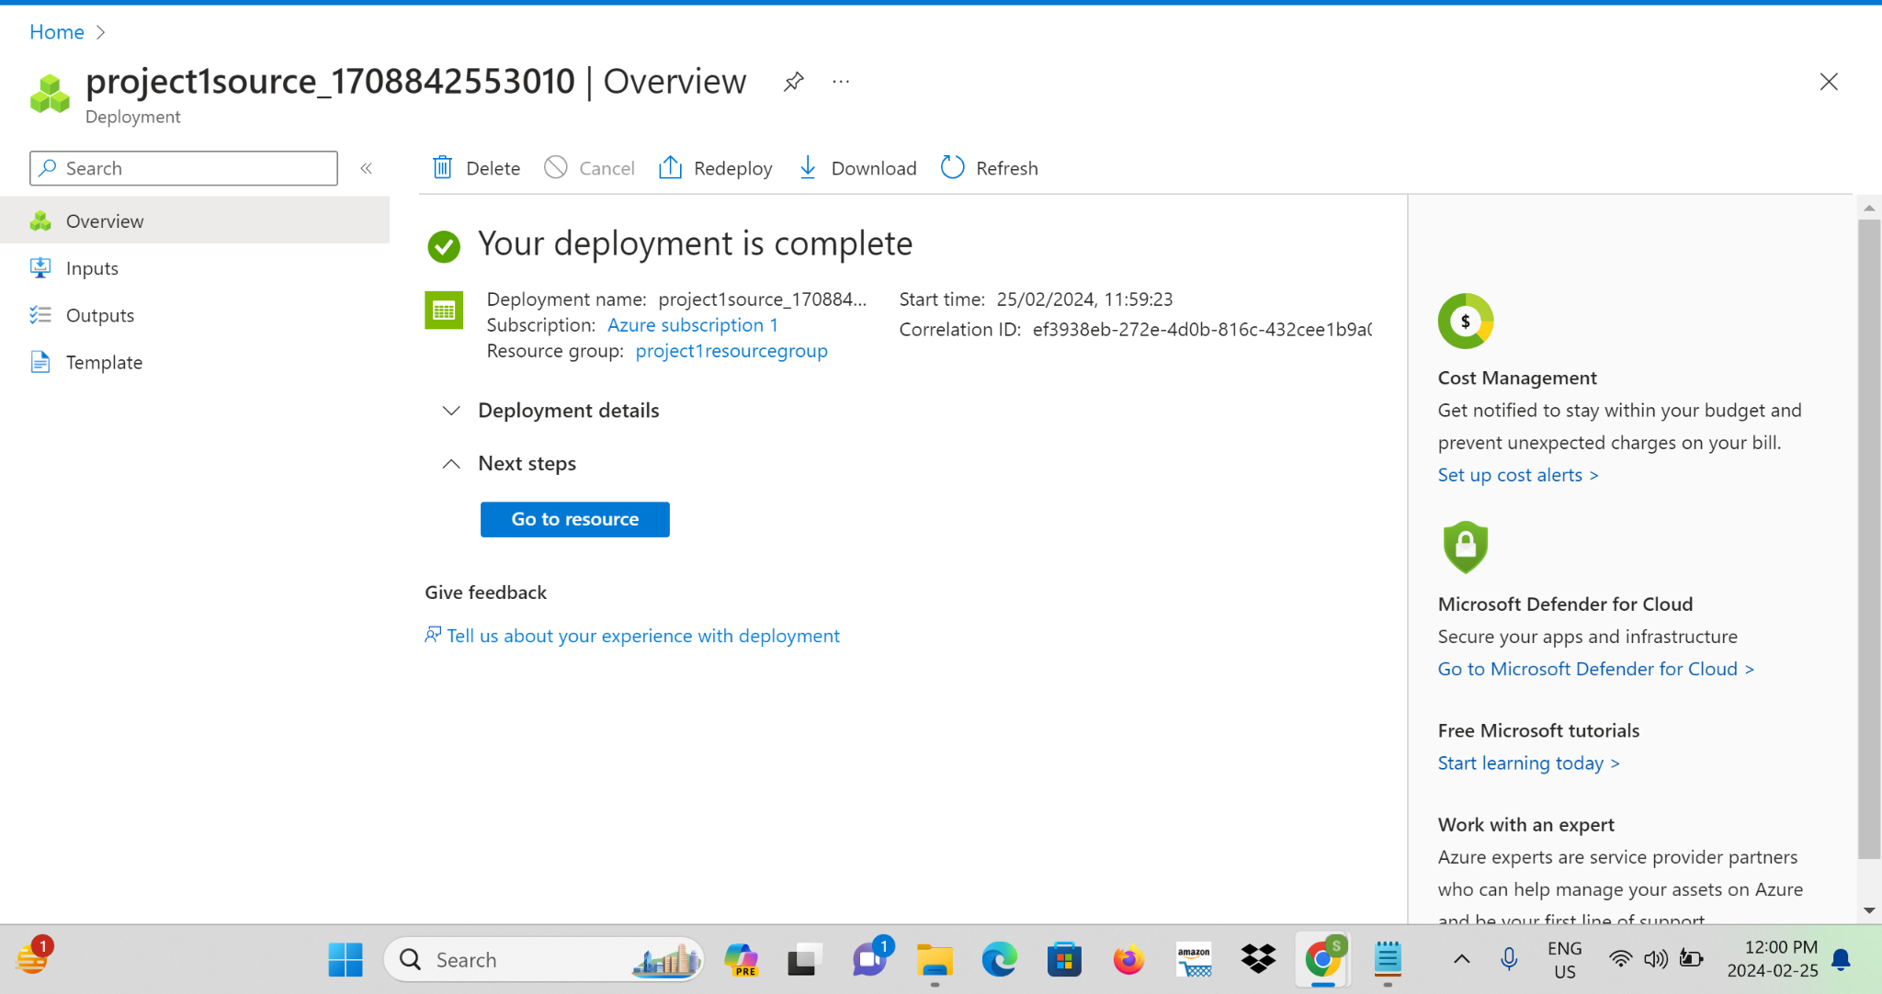

**Step 3:** After completing the storage account go to resource and search for the container.This is to upload files in the source storage account.

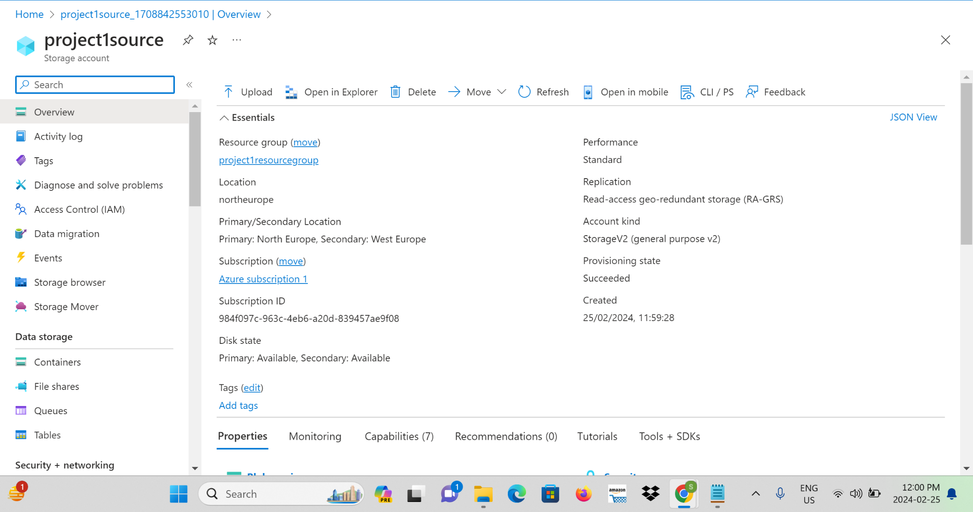

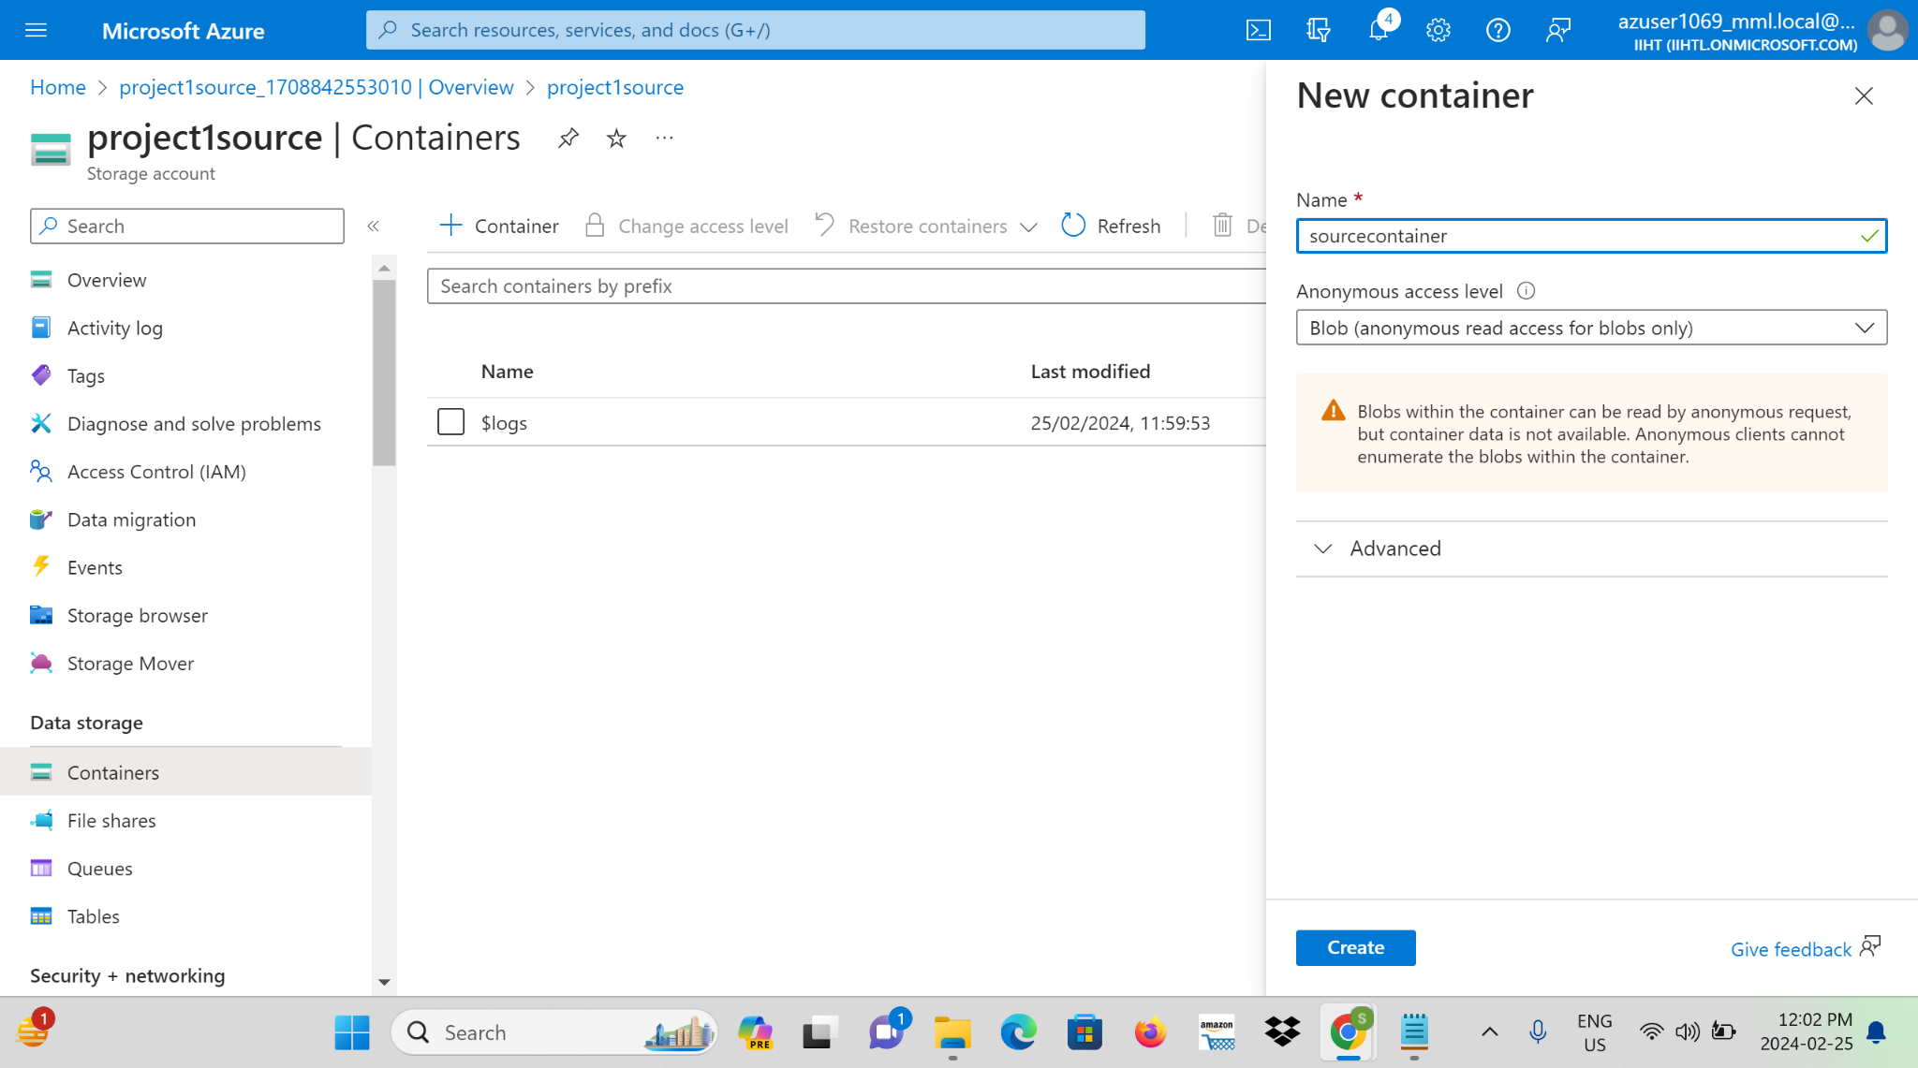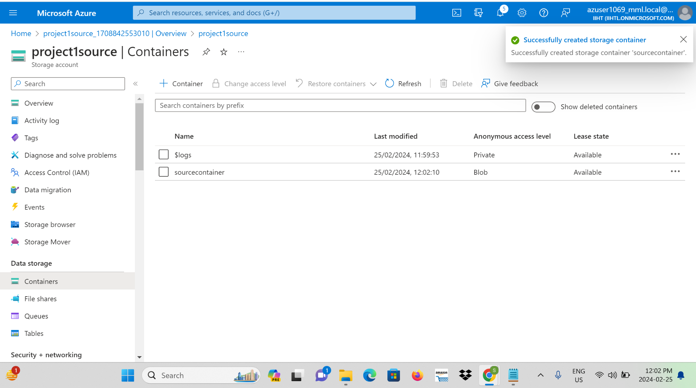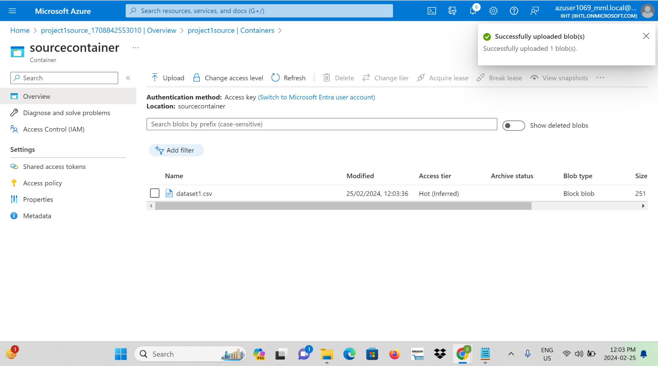

**Step 4:** Create another storage account and name it as a destination storage account and also create an empty container in it.

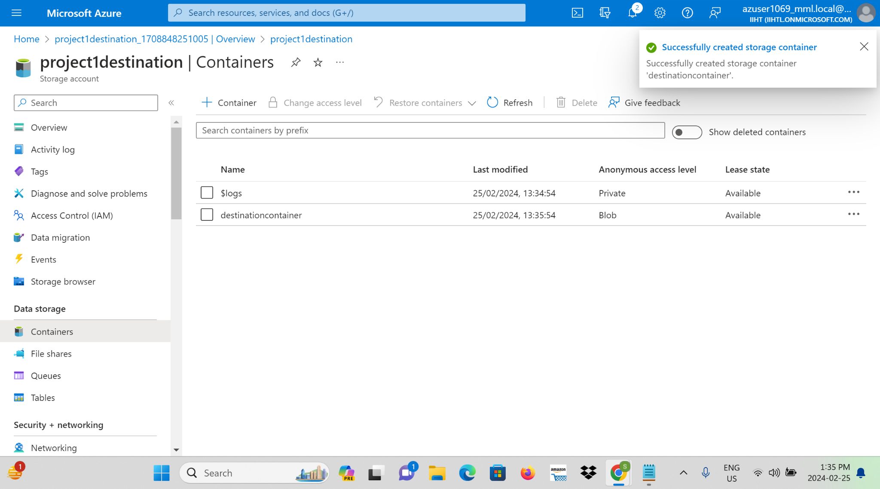

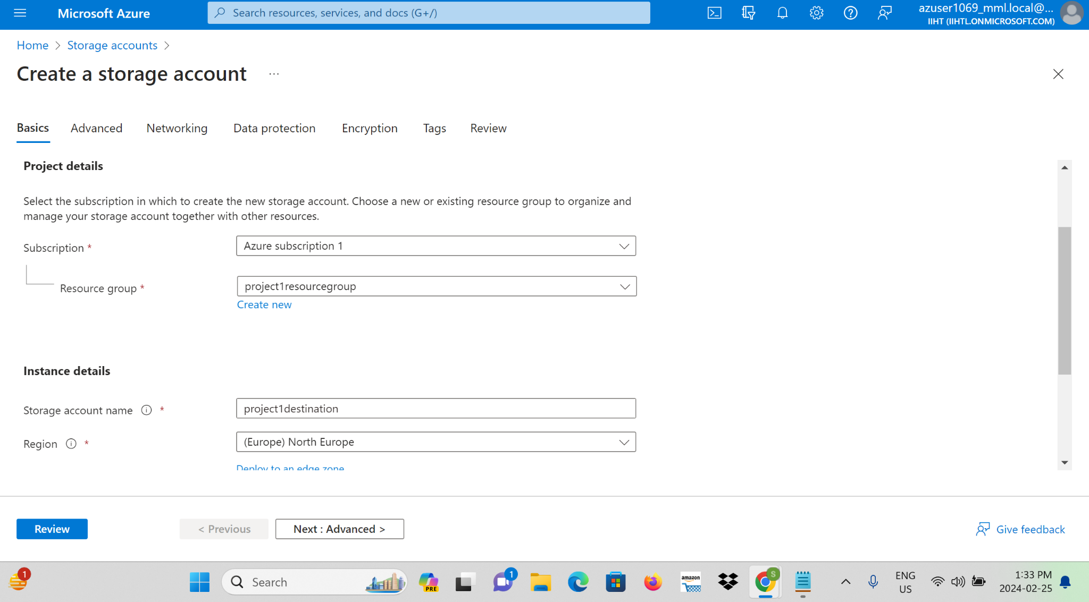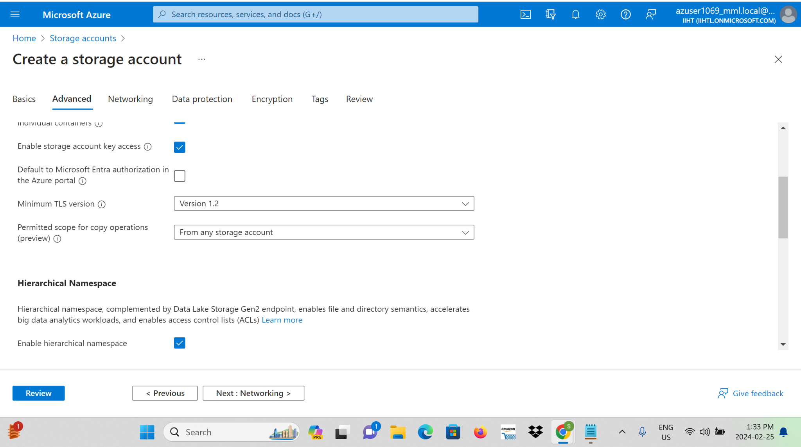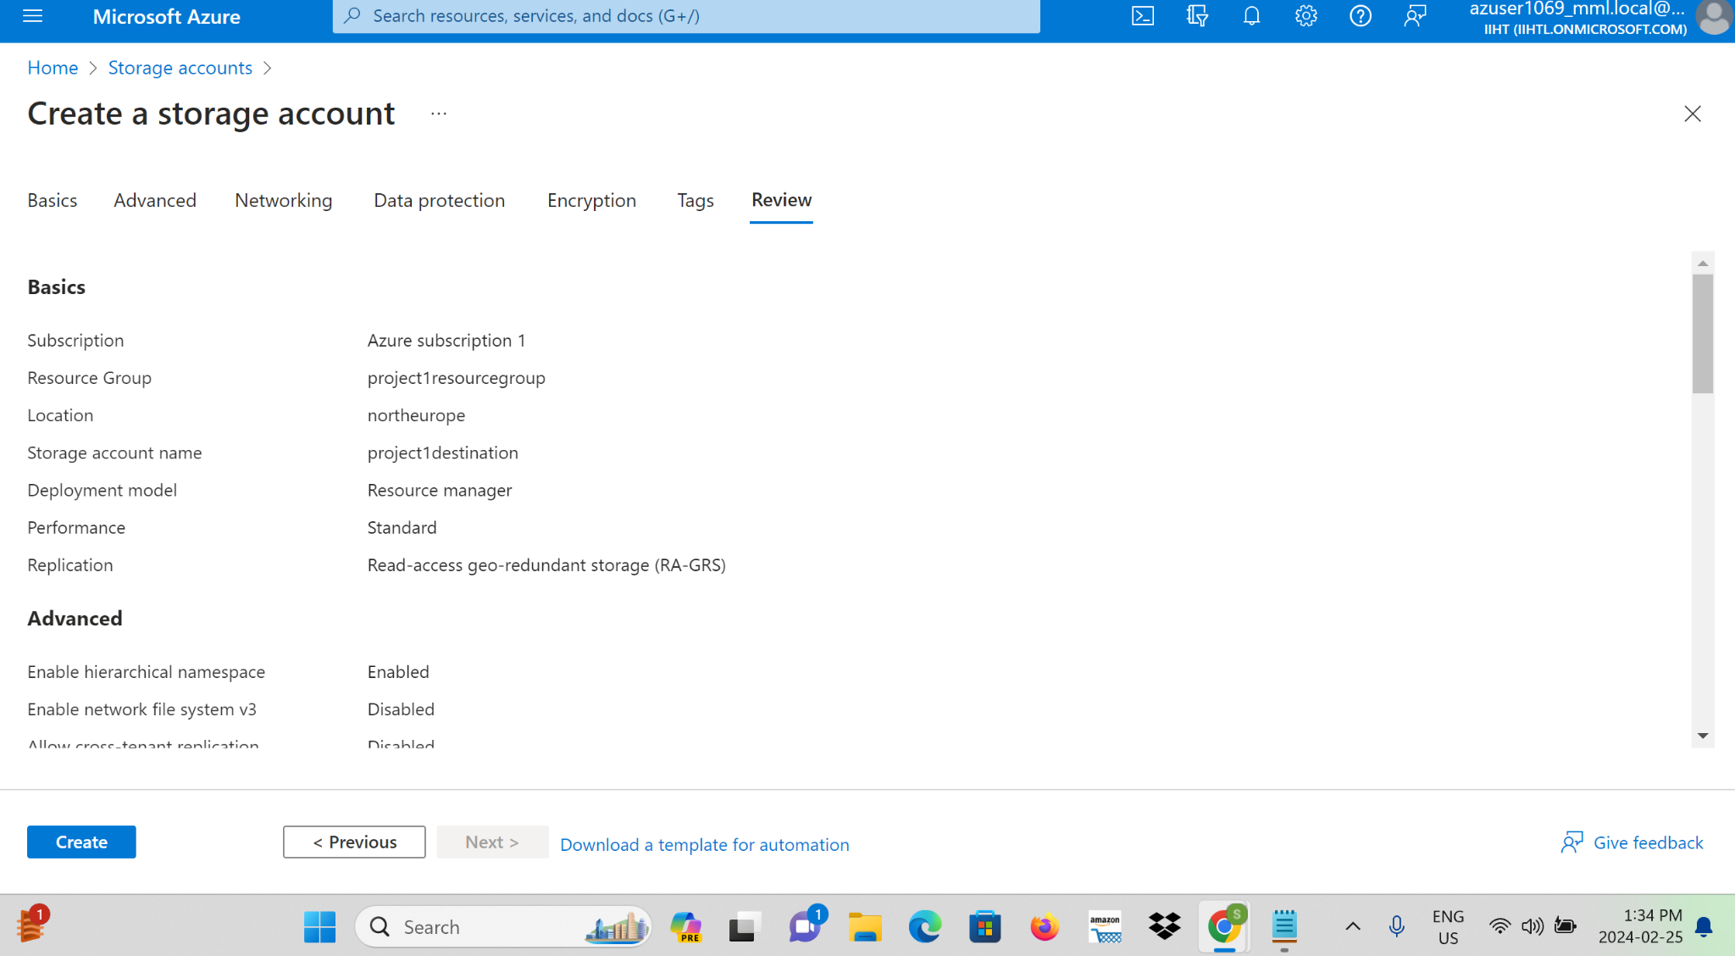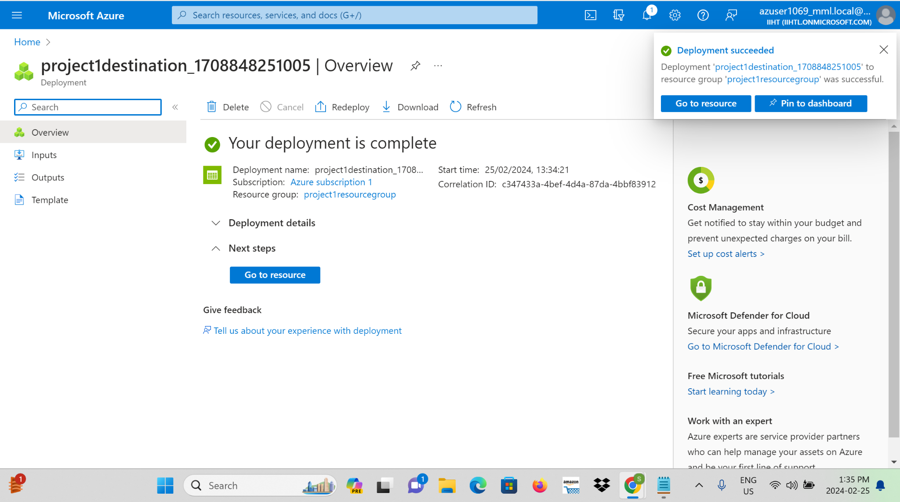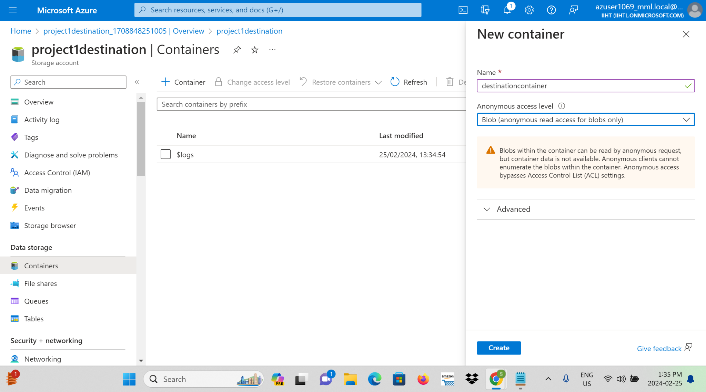

**Step 5:** Navigate to the Azure portal and search for Azure Data Factory and create a Data Factory.

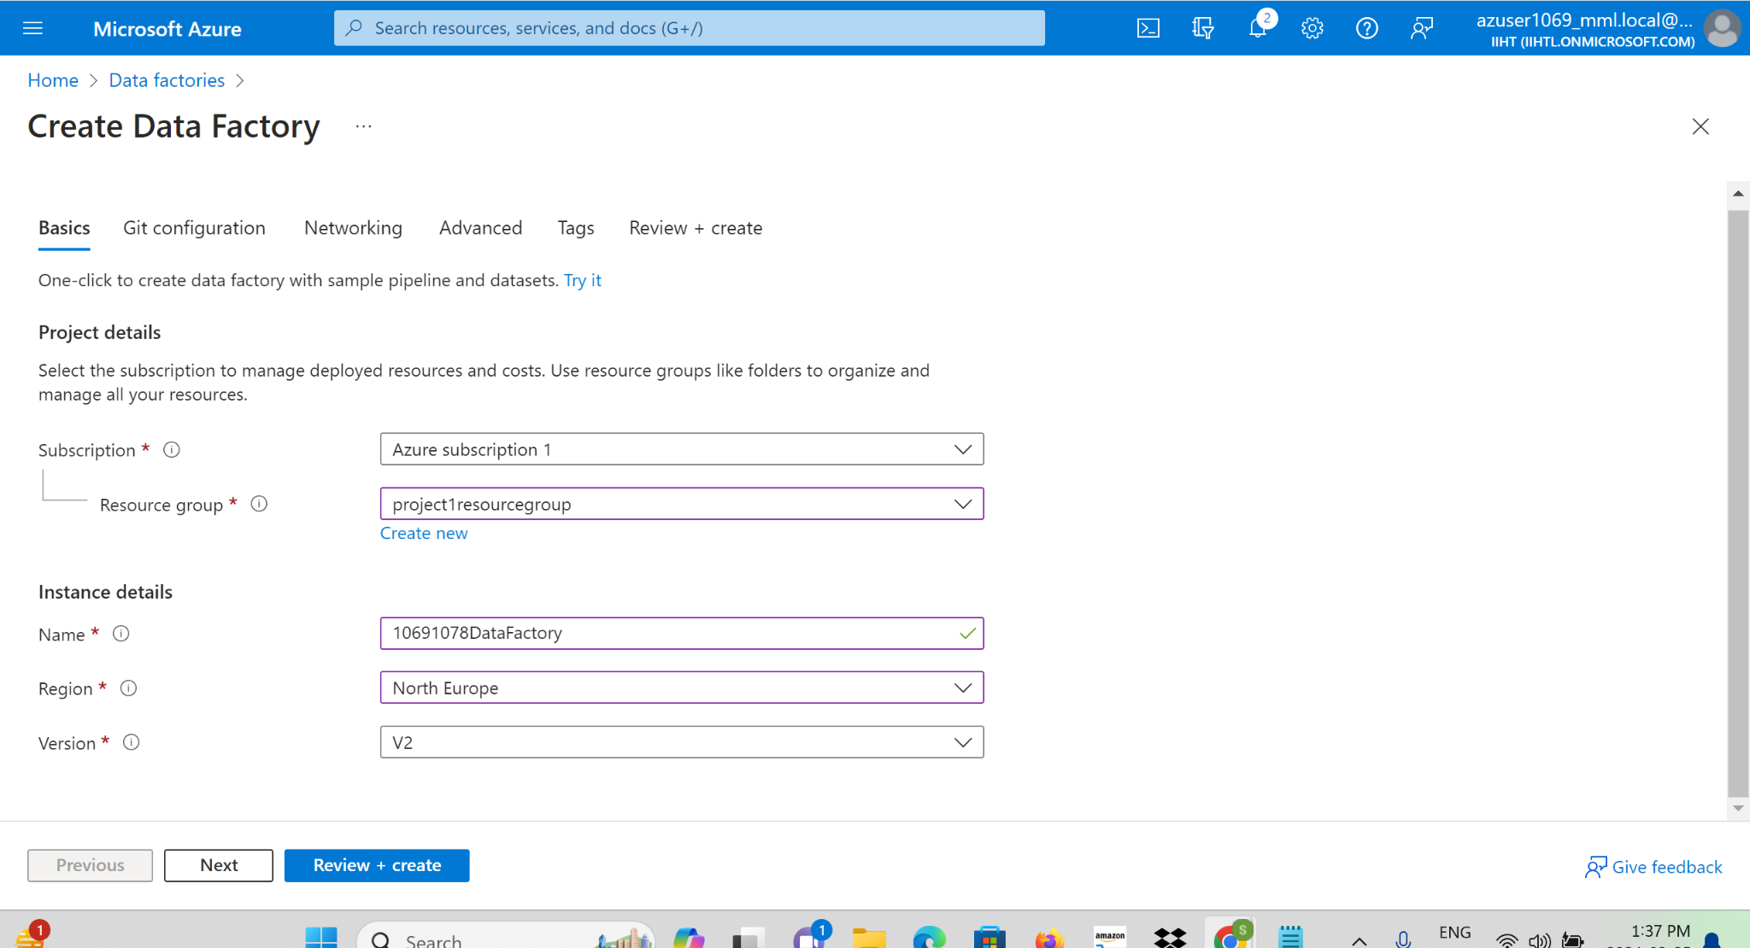

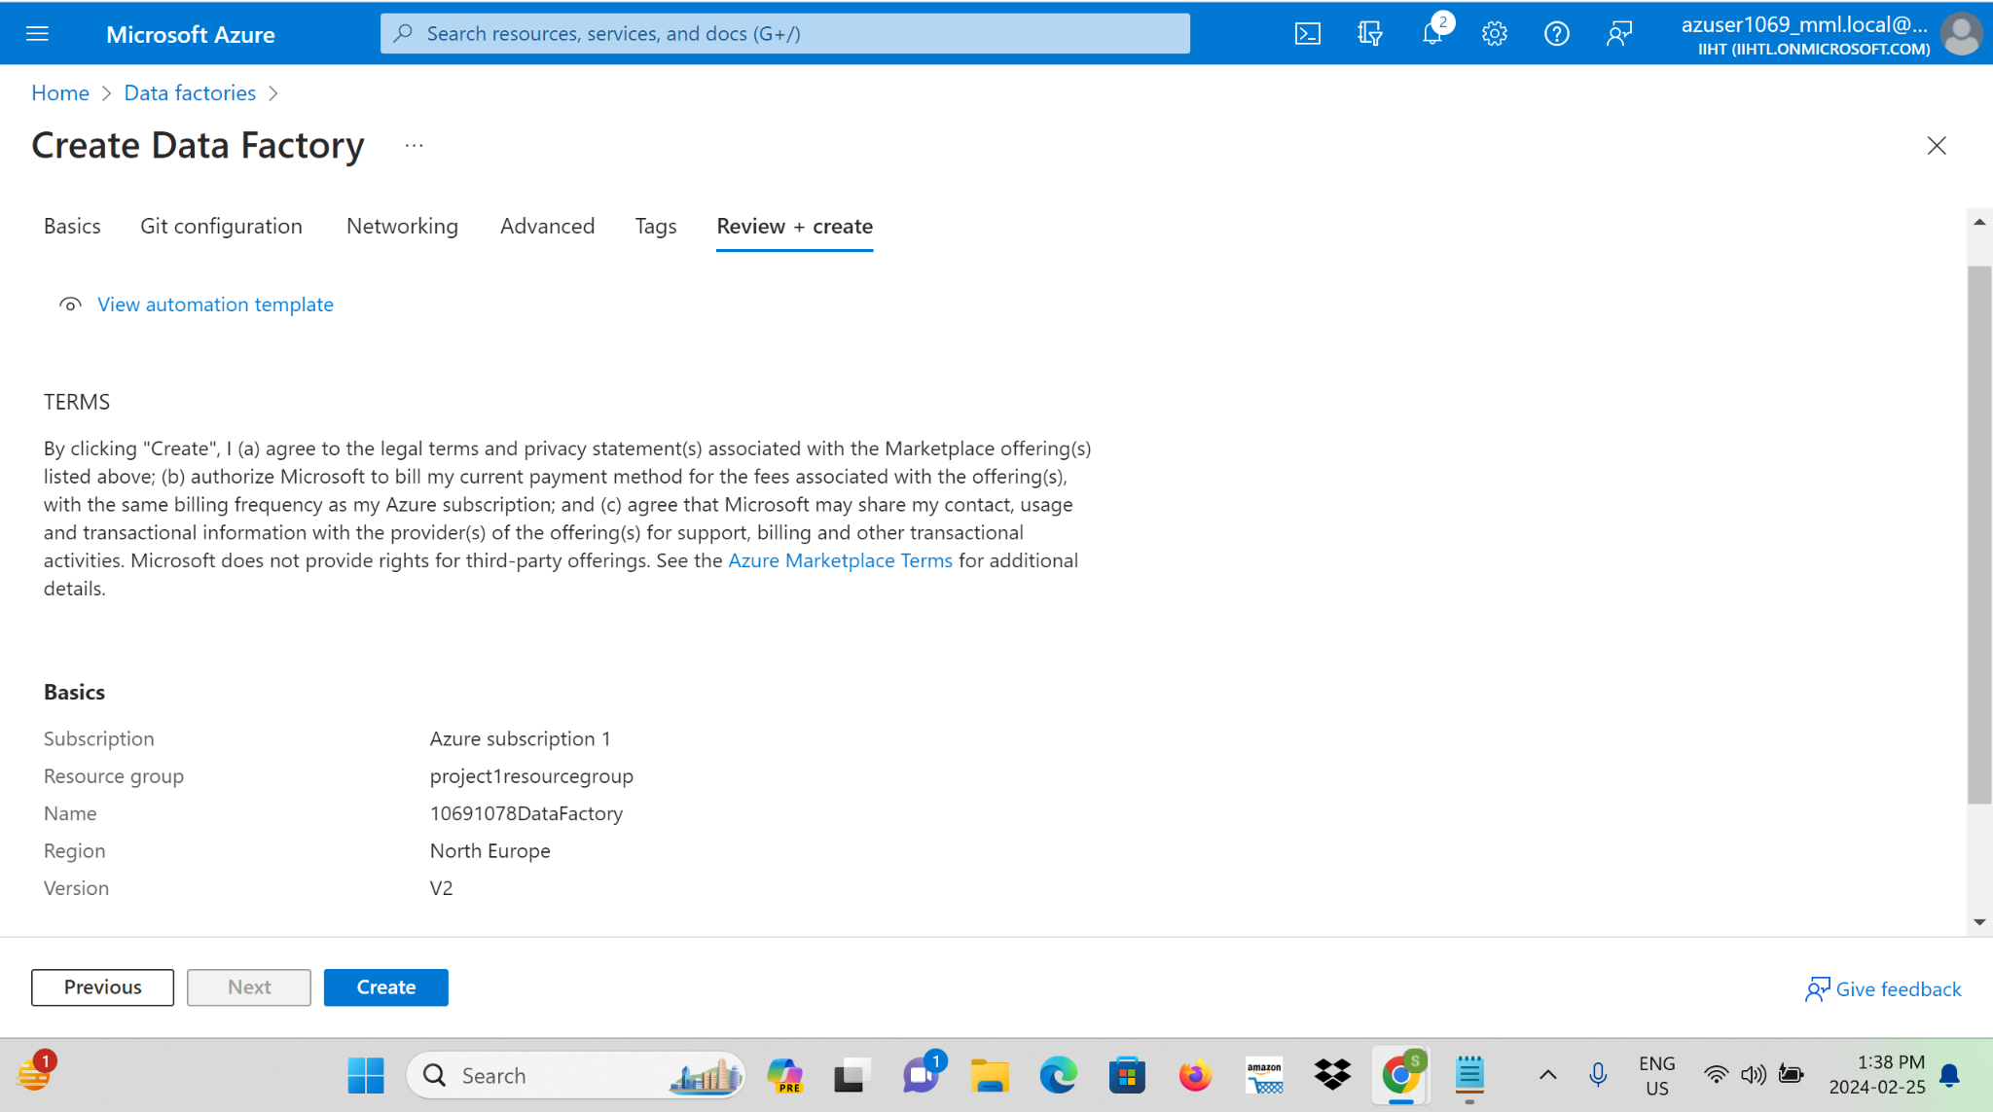

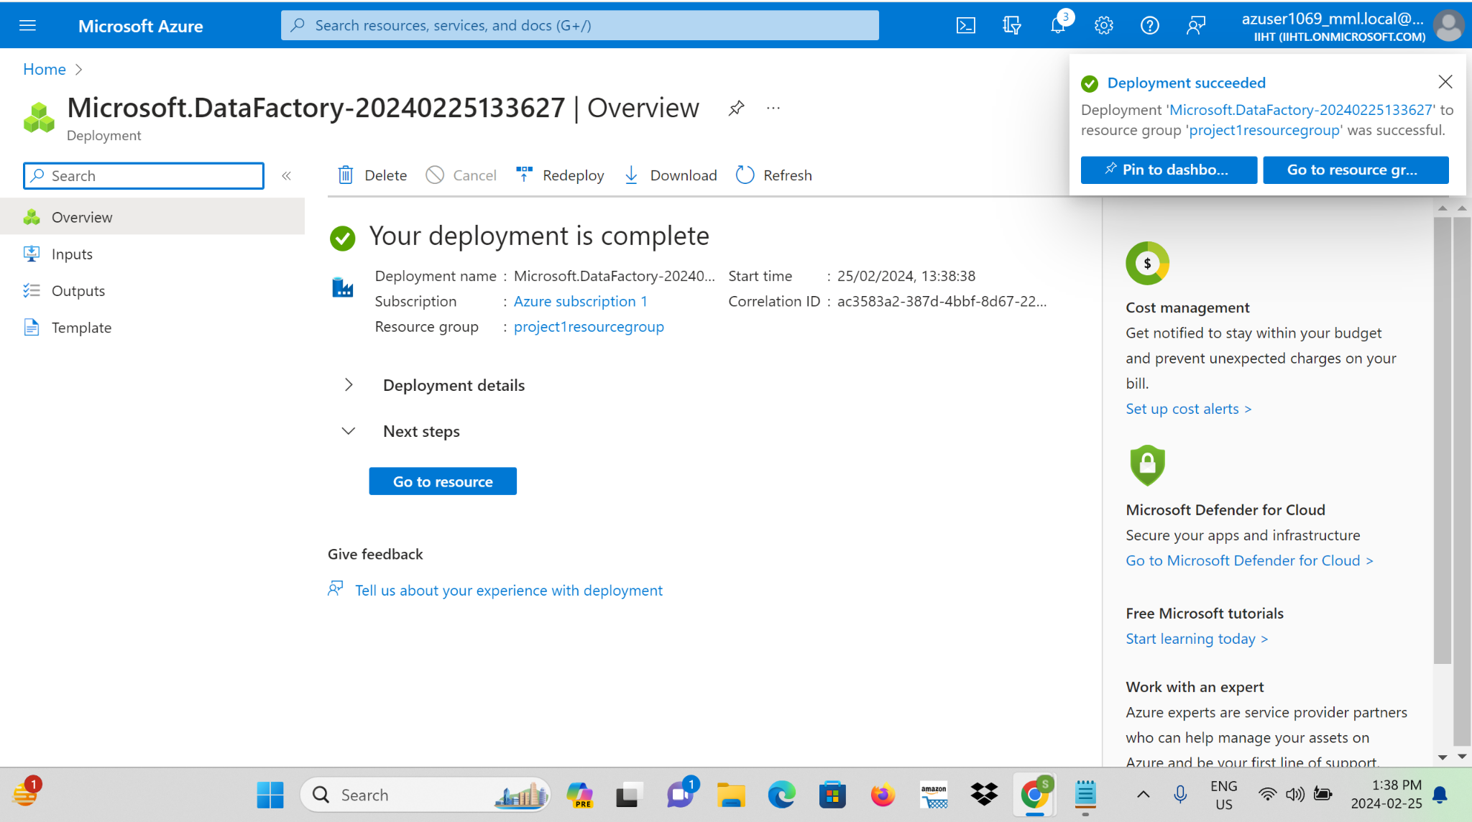

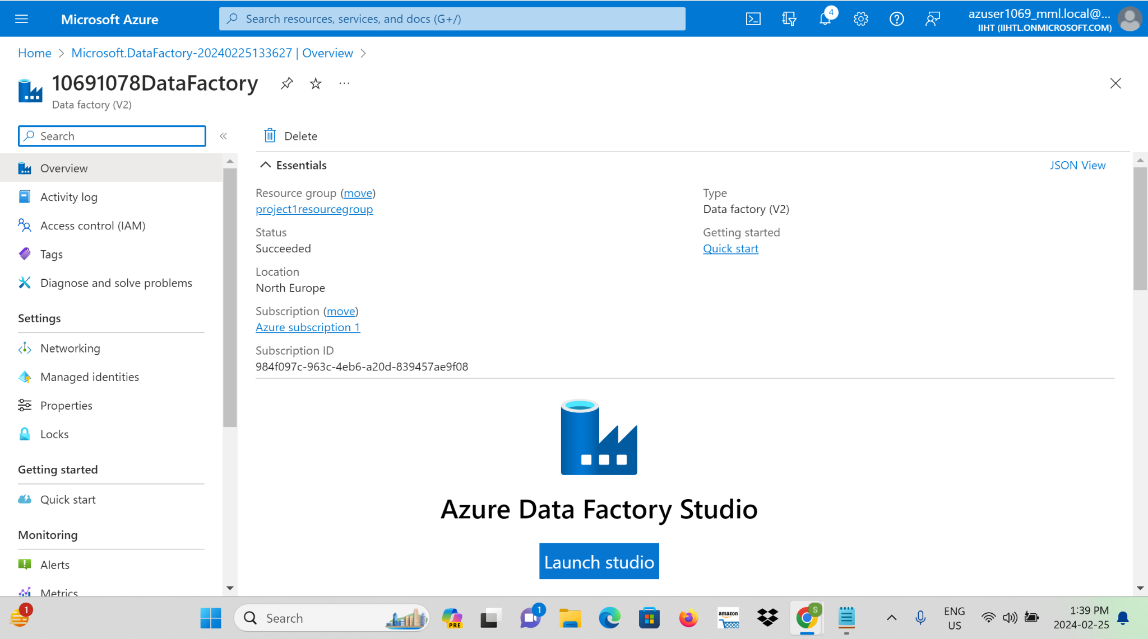

**Step 6:** Create Data Factory Pipelines utilise Azure Data Factory to design and implement data pipelines for ingesting data.

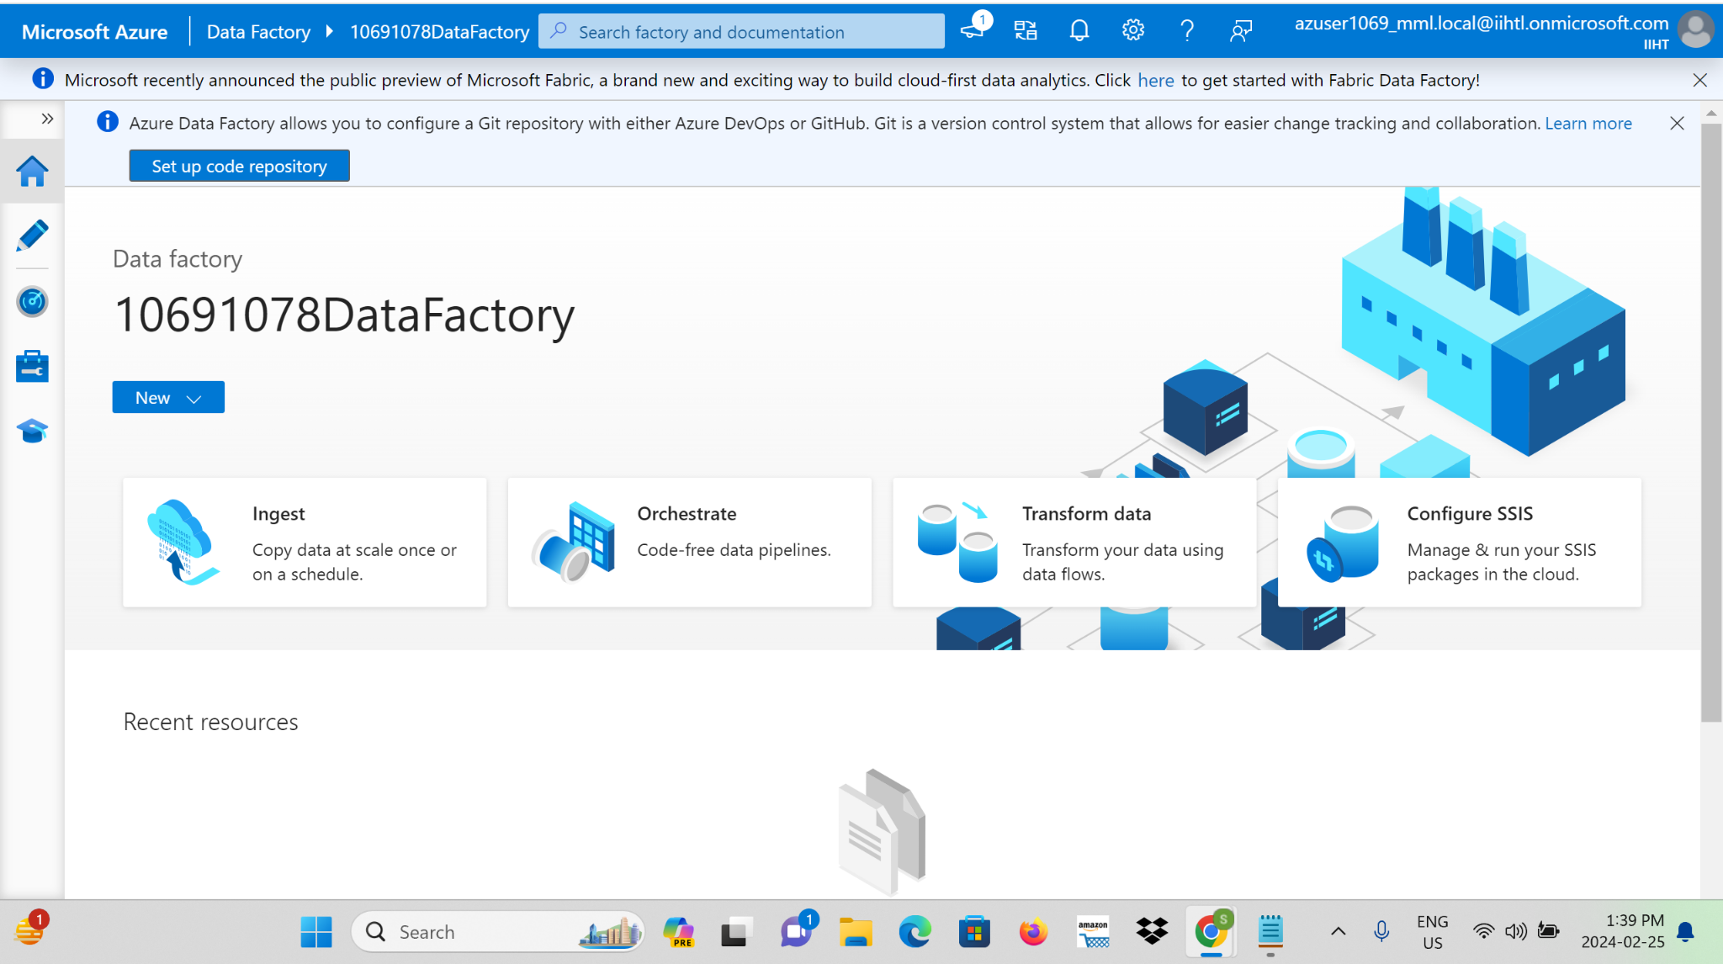

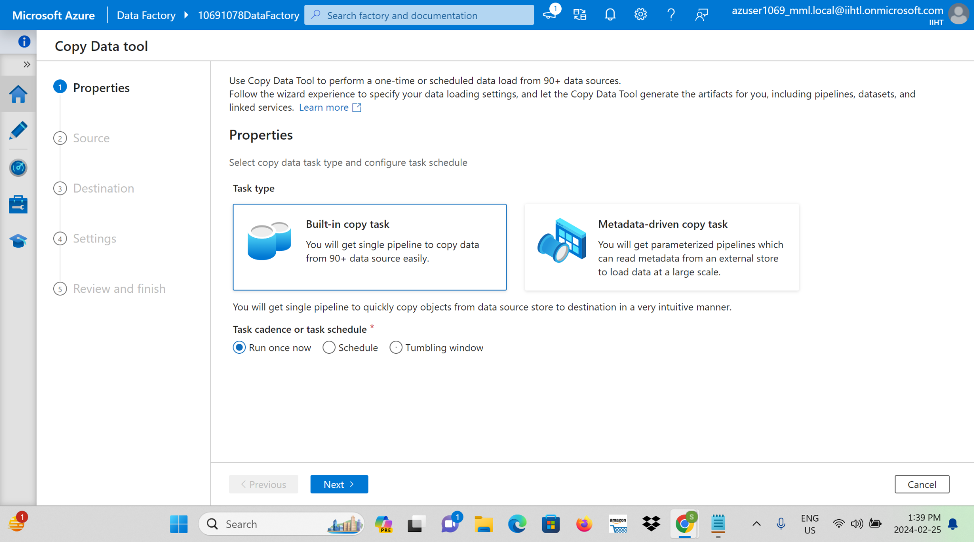

**Step 7:**Configure Blob Storage as source, specify Azure Blob Storage as the target for ingested data and give a file path to browse the file Where needed, set up real-time data ingestion to ensure timely processing.

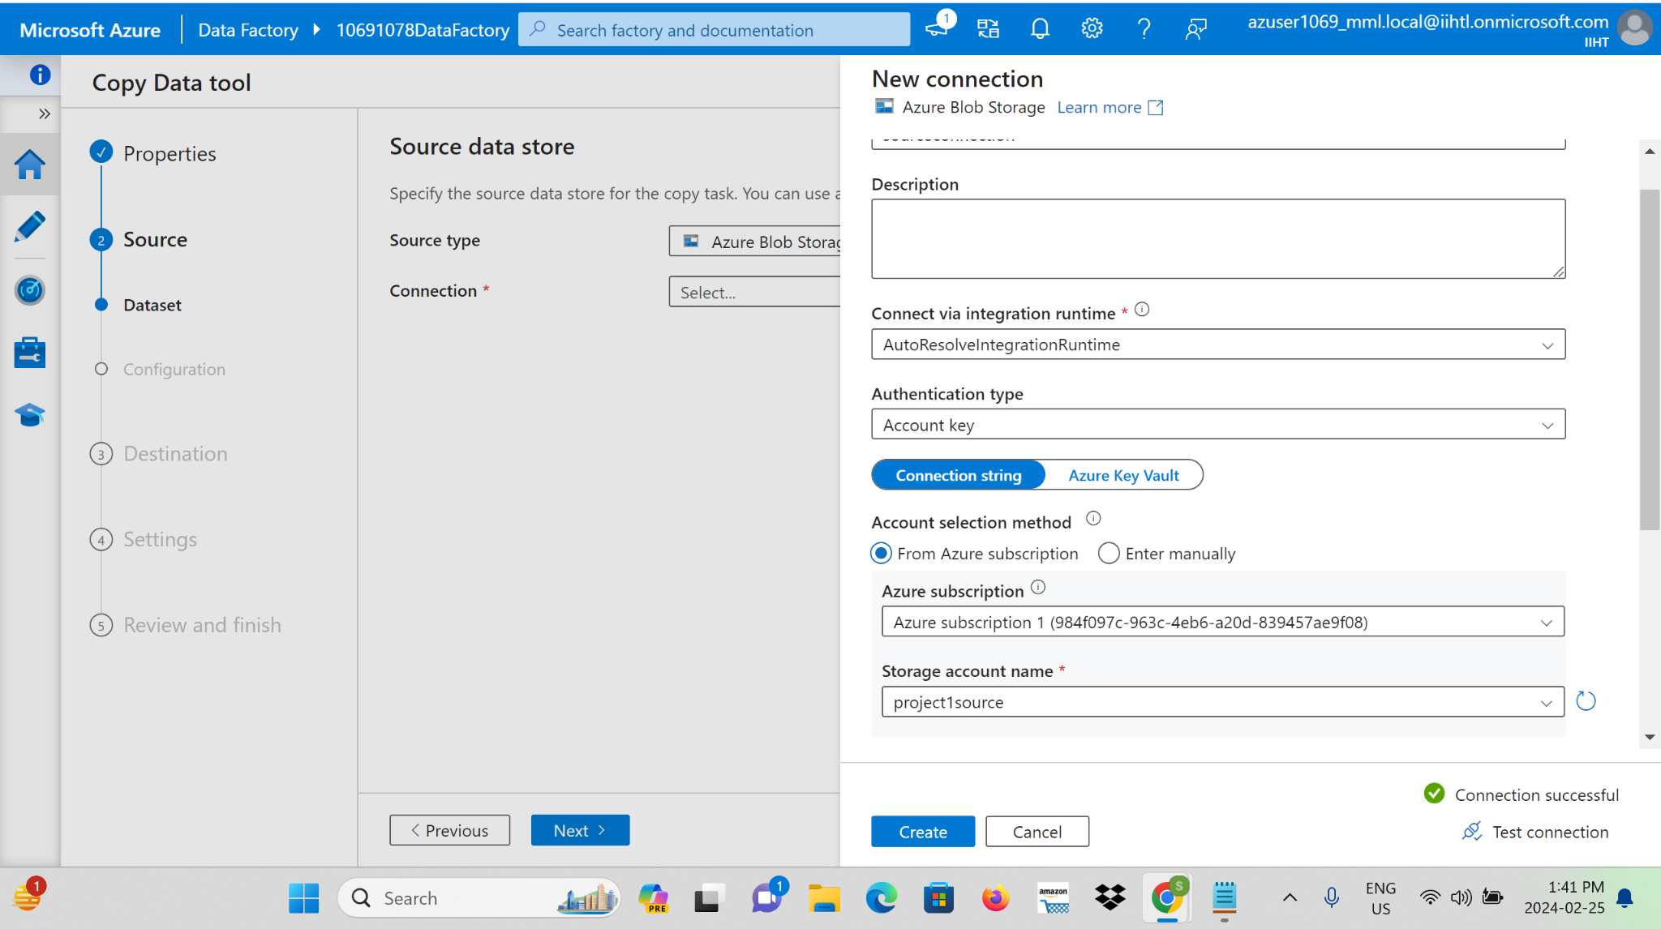

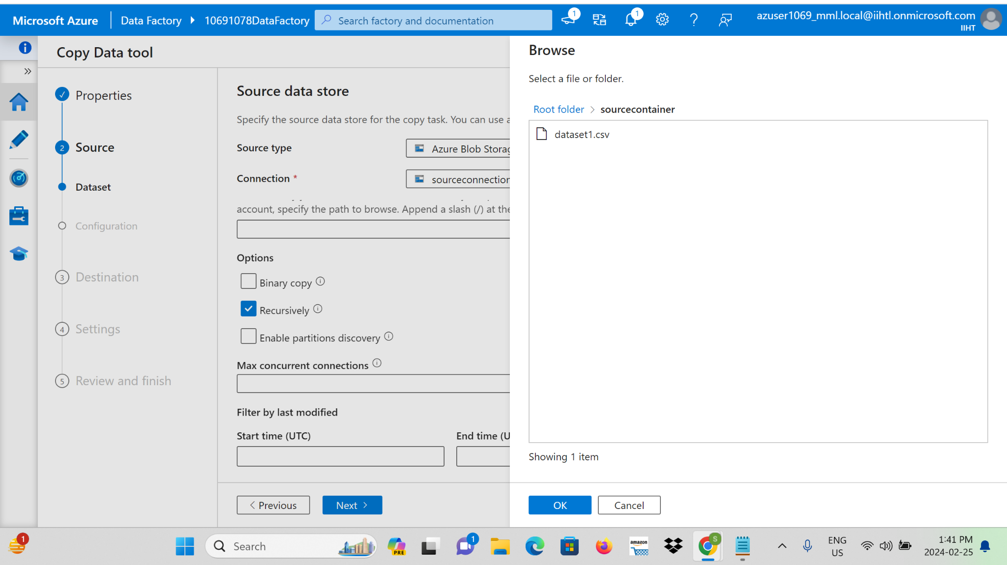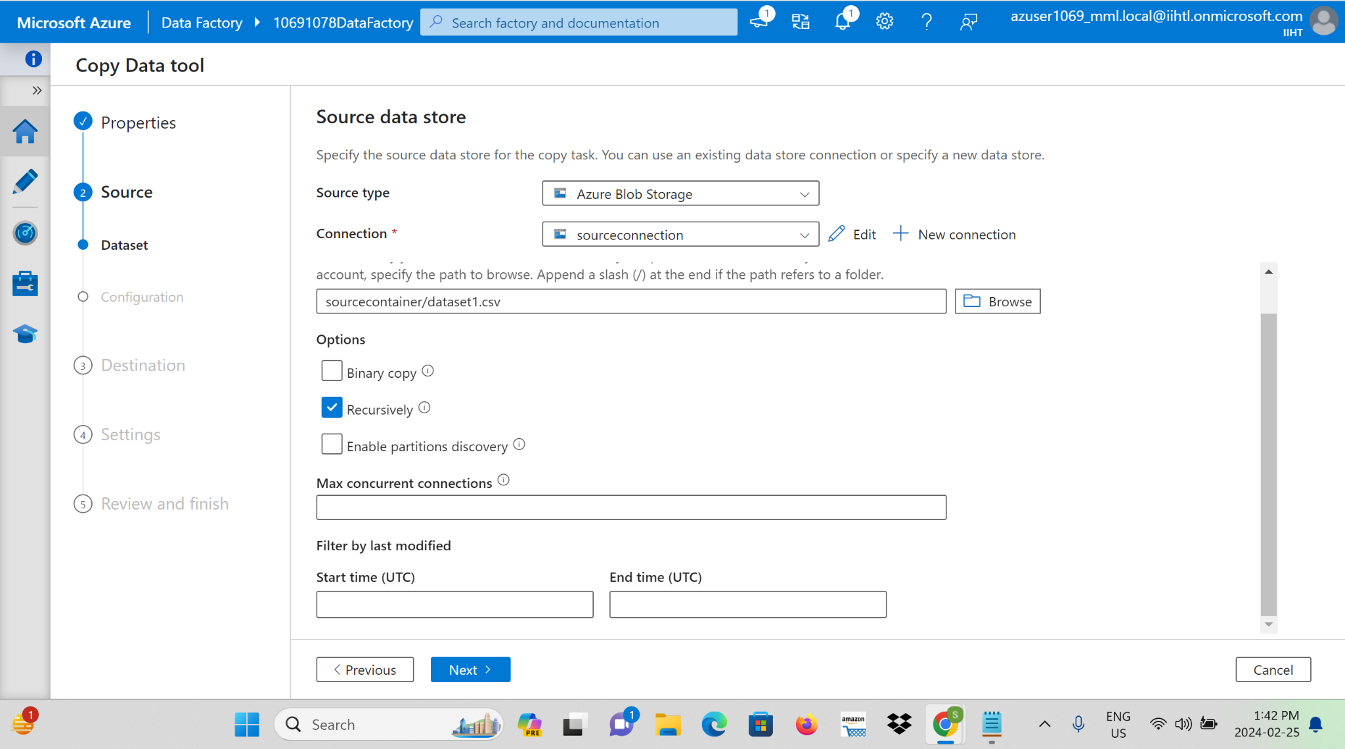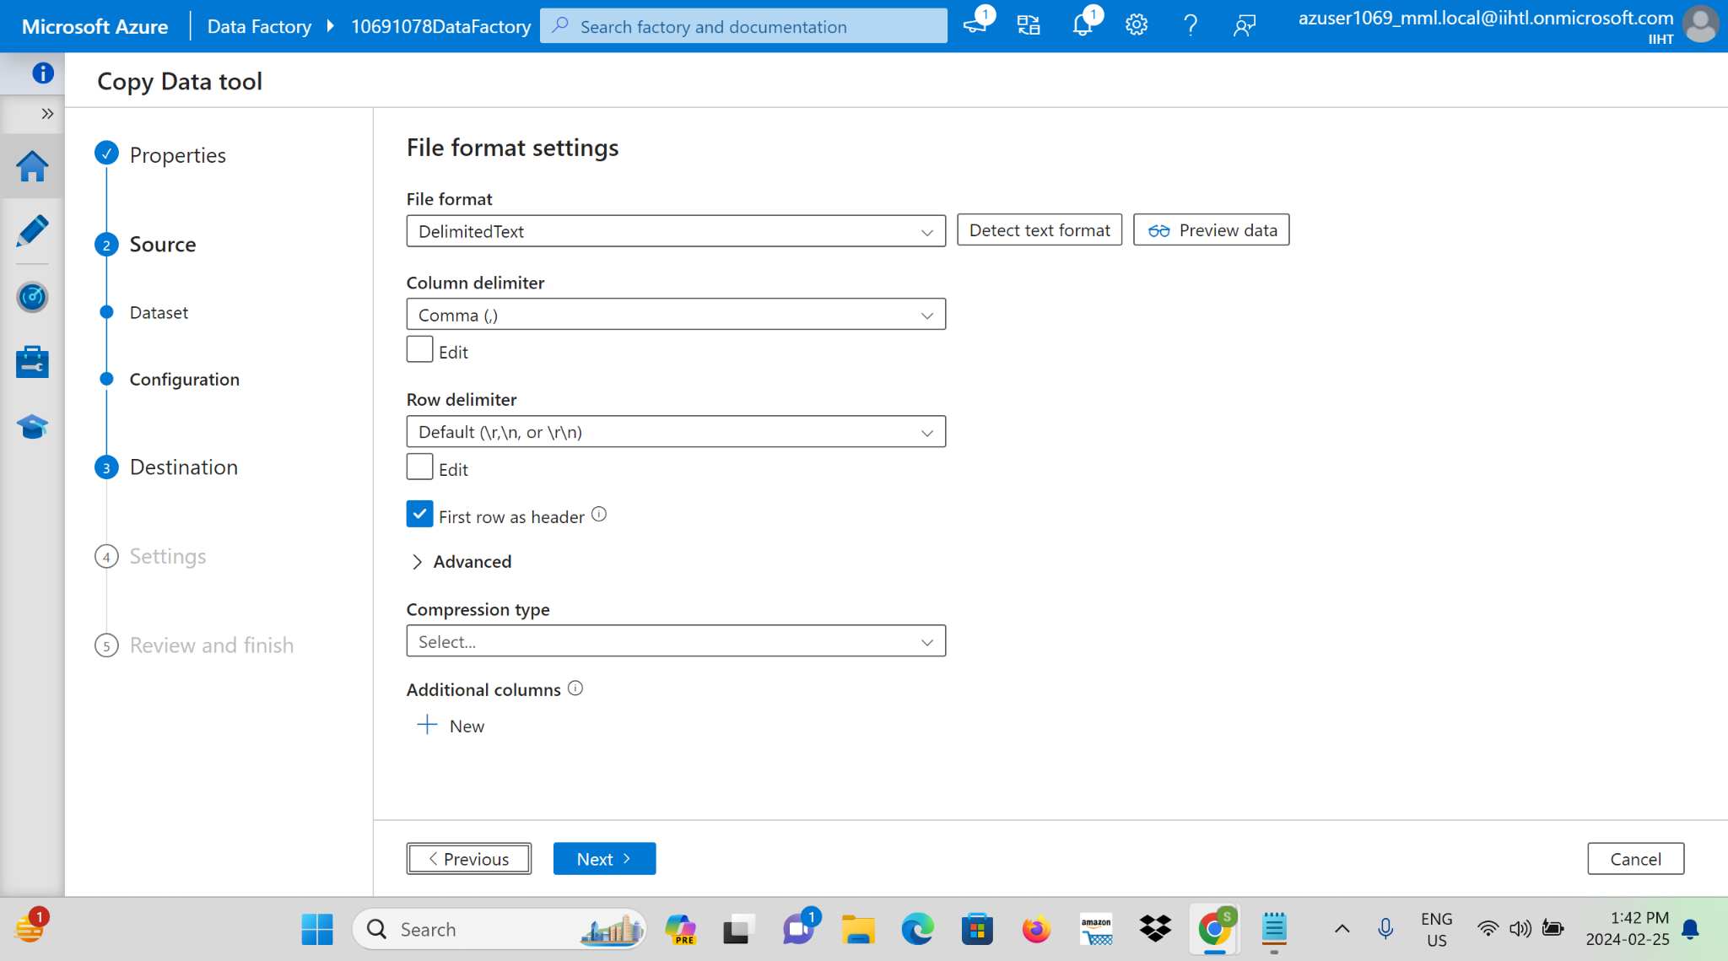

**Step 8:**Configure Blob Storage as source, specify Azure Blob Storage as the target for ingested data and give a file path to browse the file Where needed, set up real-time data ingestion to ensure timely processing.

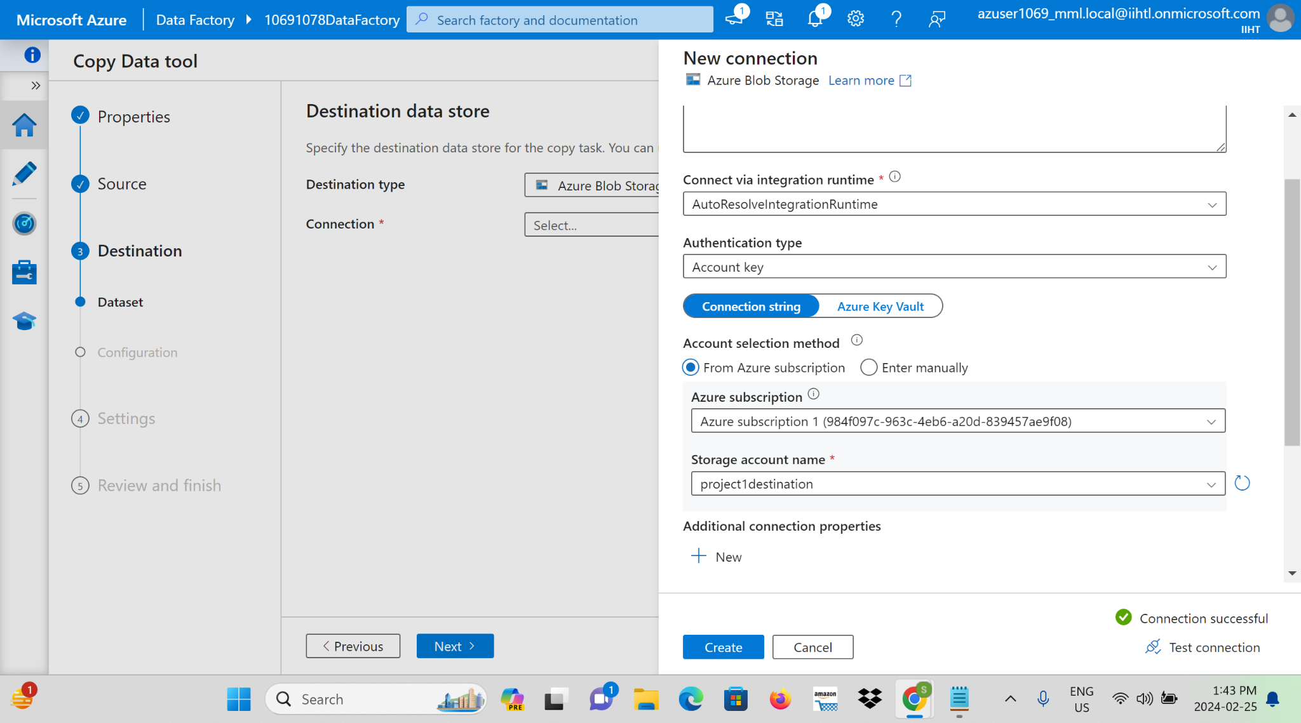

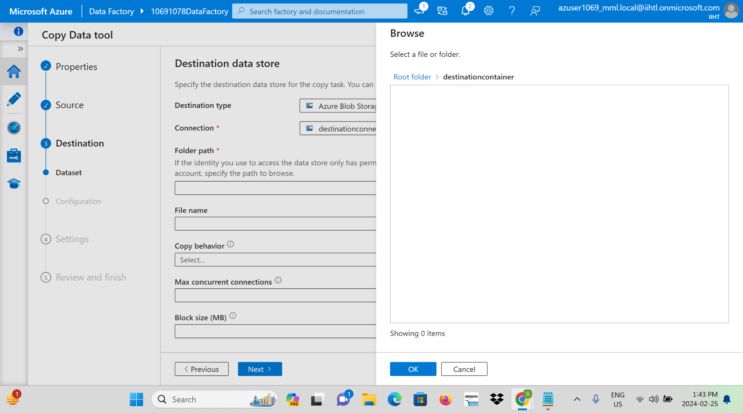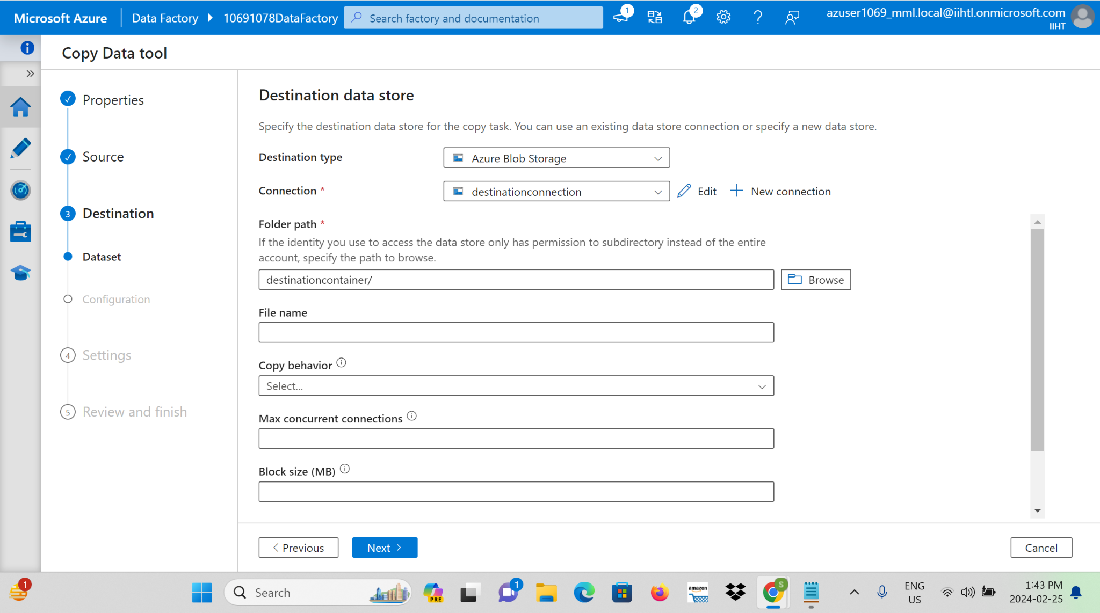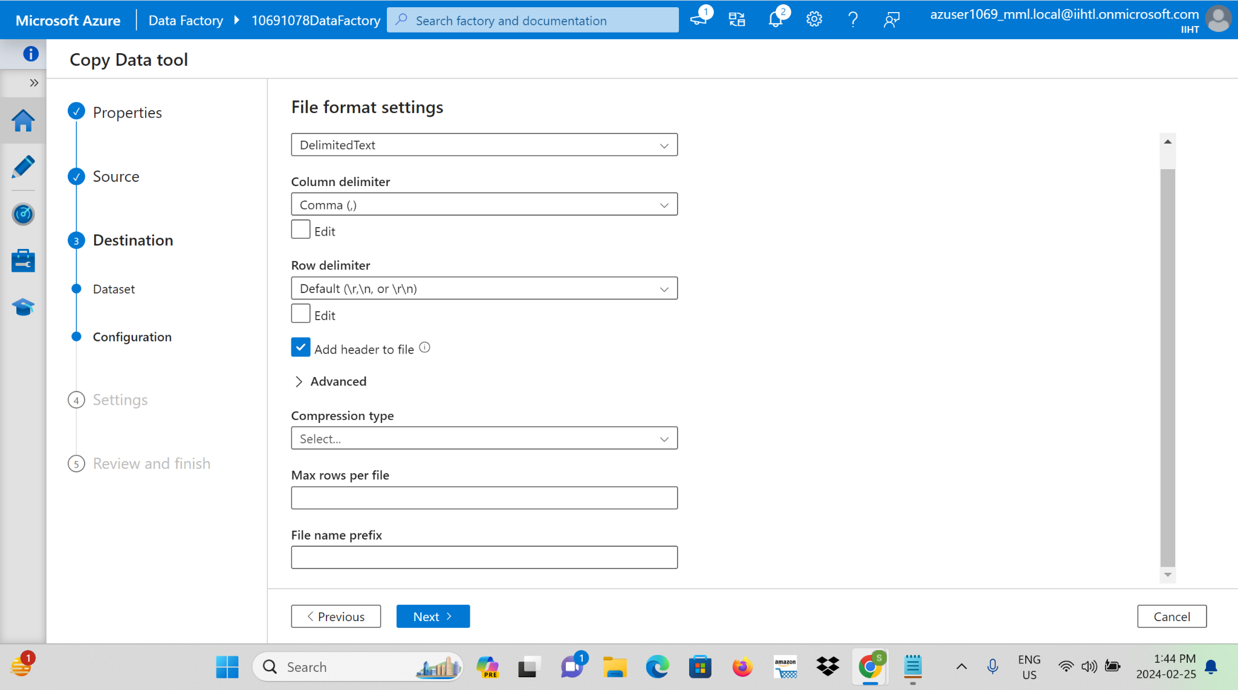

**Step 9:**We need to give the name for the copy data task .

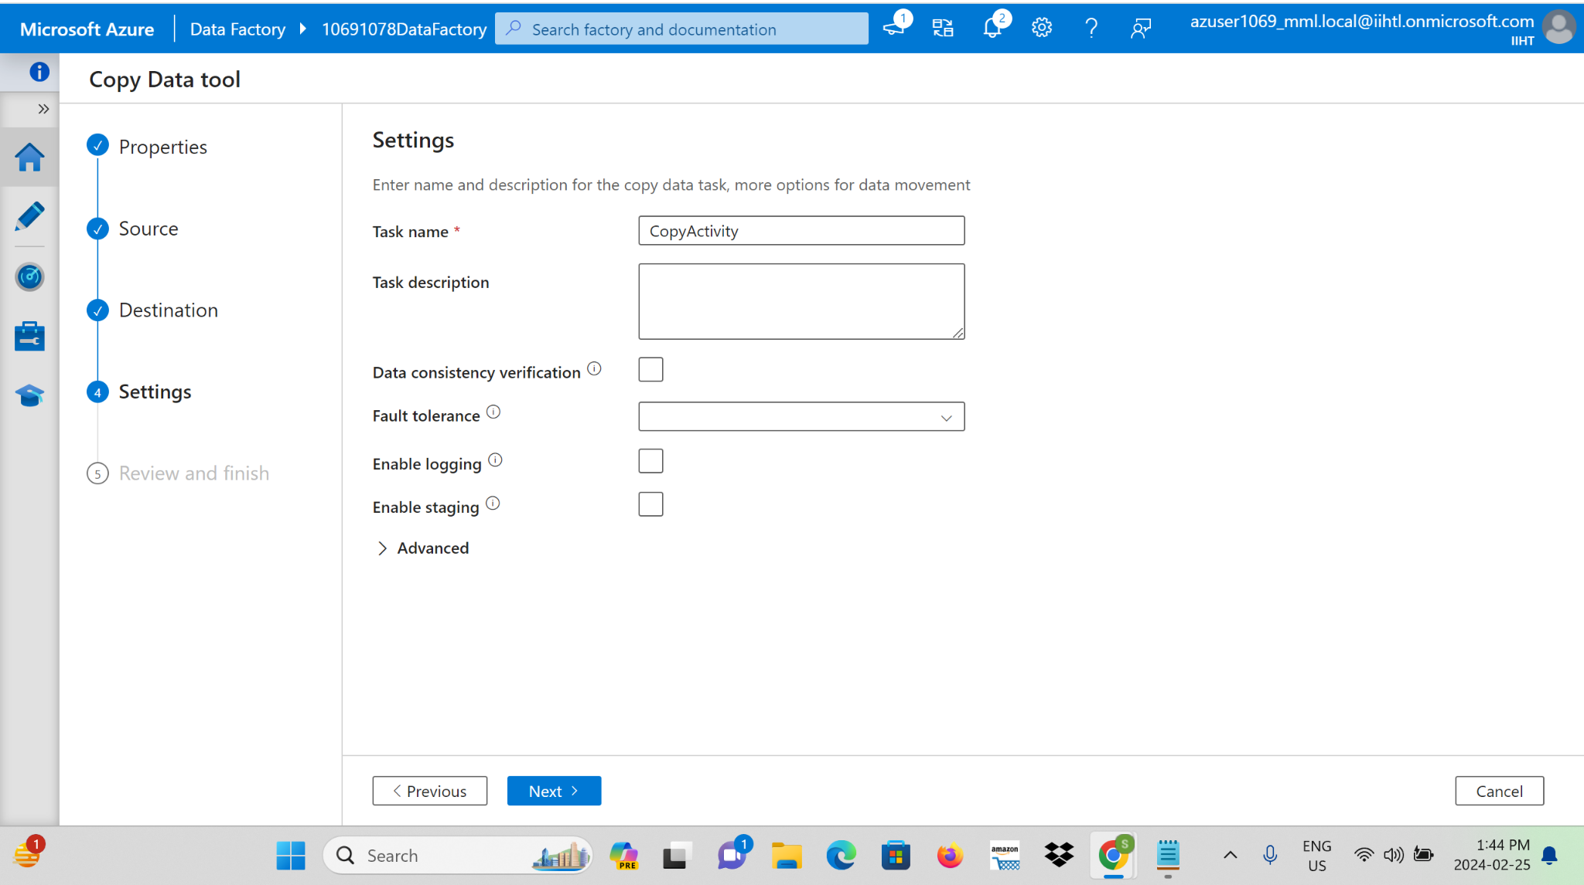

**Step 10:** Set up scheduling and orchestration within the Data Factory to ensure smooth and automated data ingestion workflows.

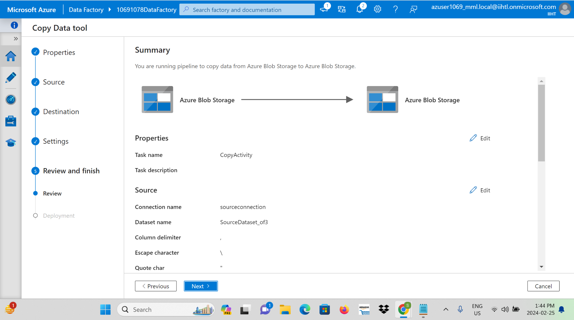

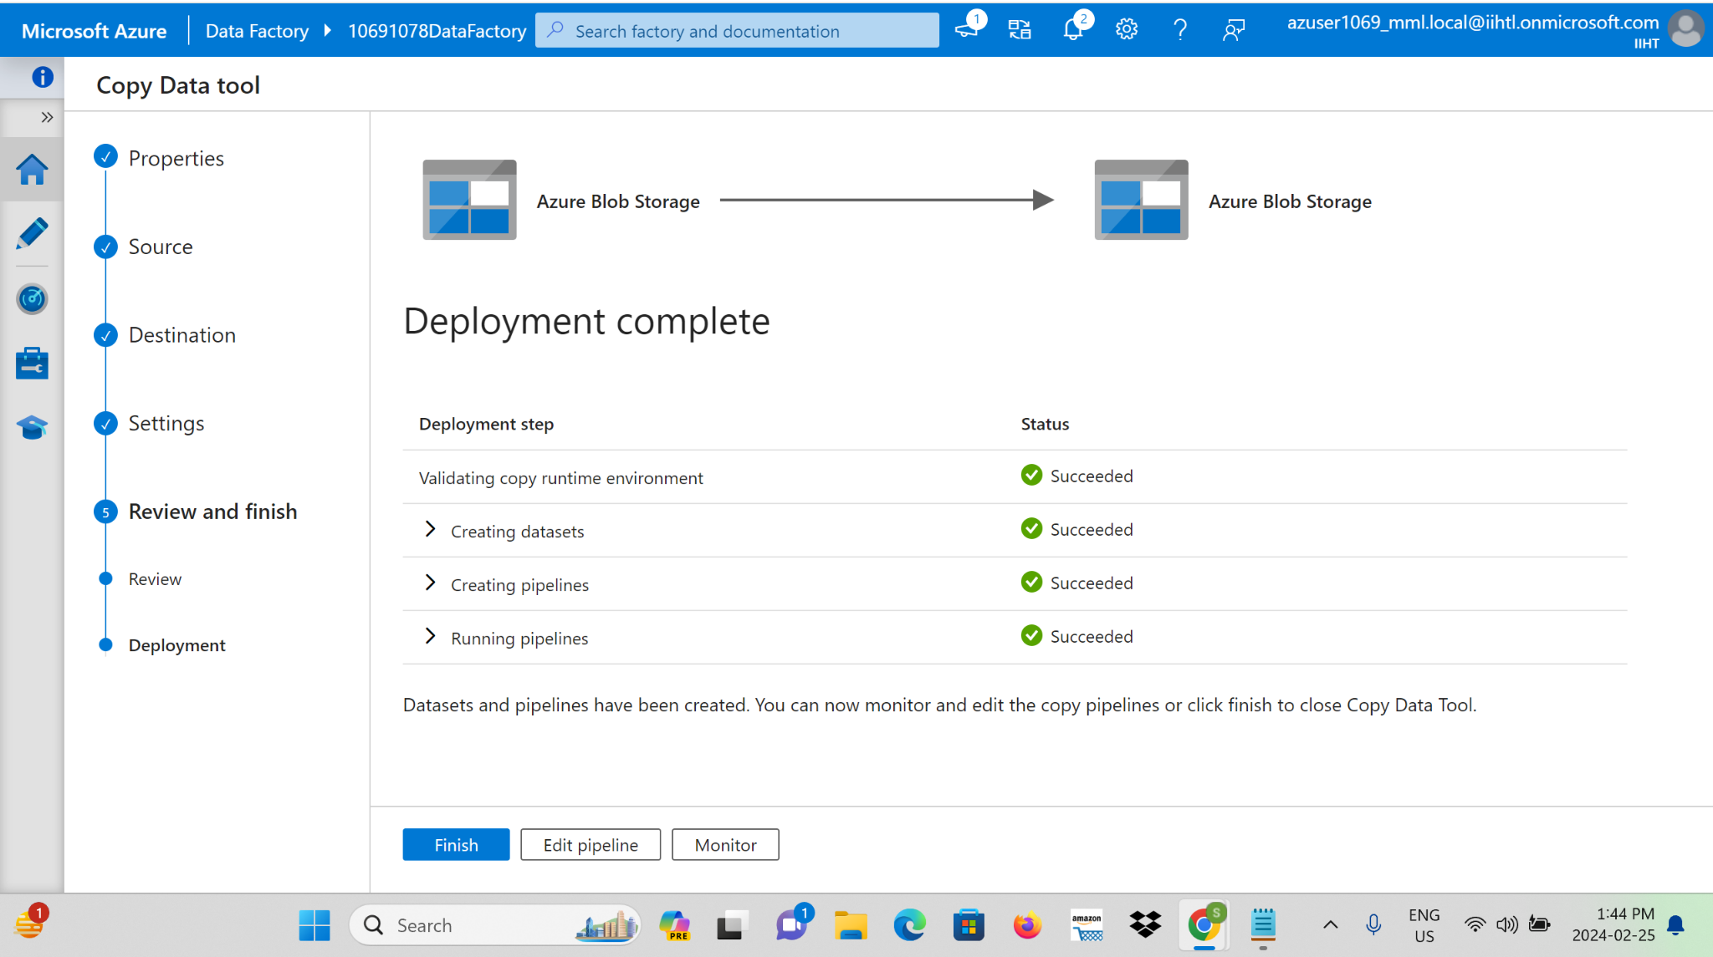

**Step 11:** Now we can see that the output for the copying activity in Azure Data Factory is the successful transfer of data from a source data store to a destination data store.

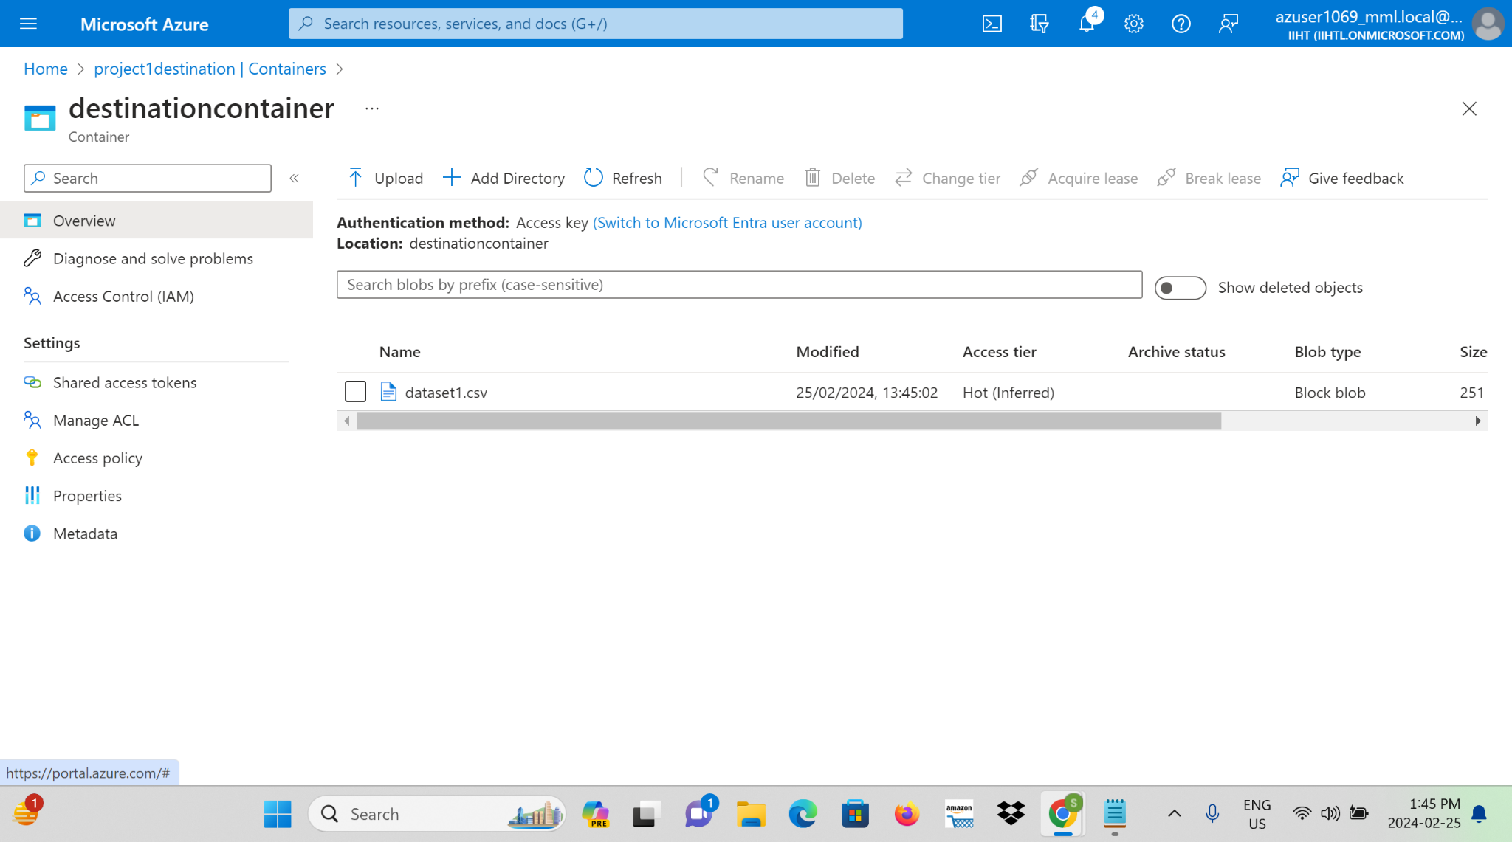

**Step 12:** validating and debugging the copy activity.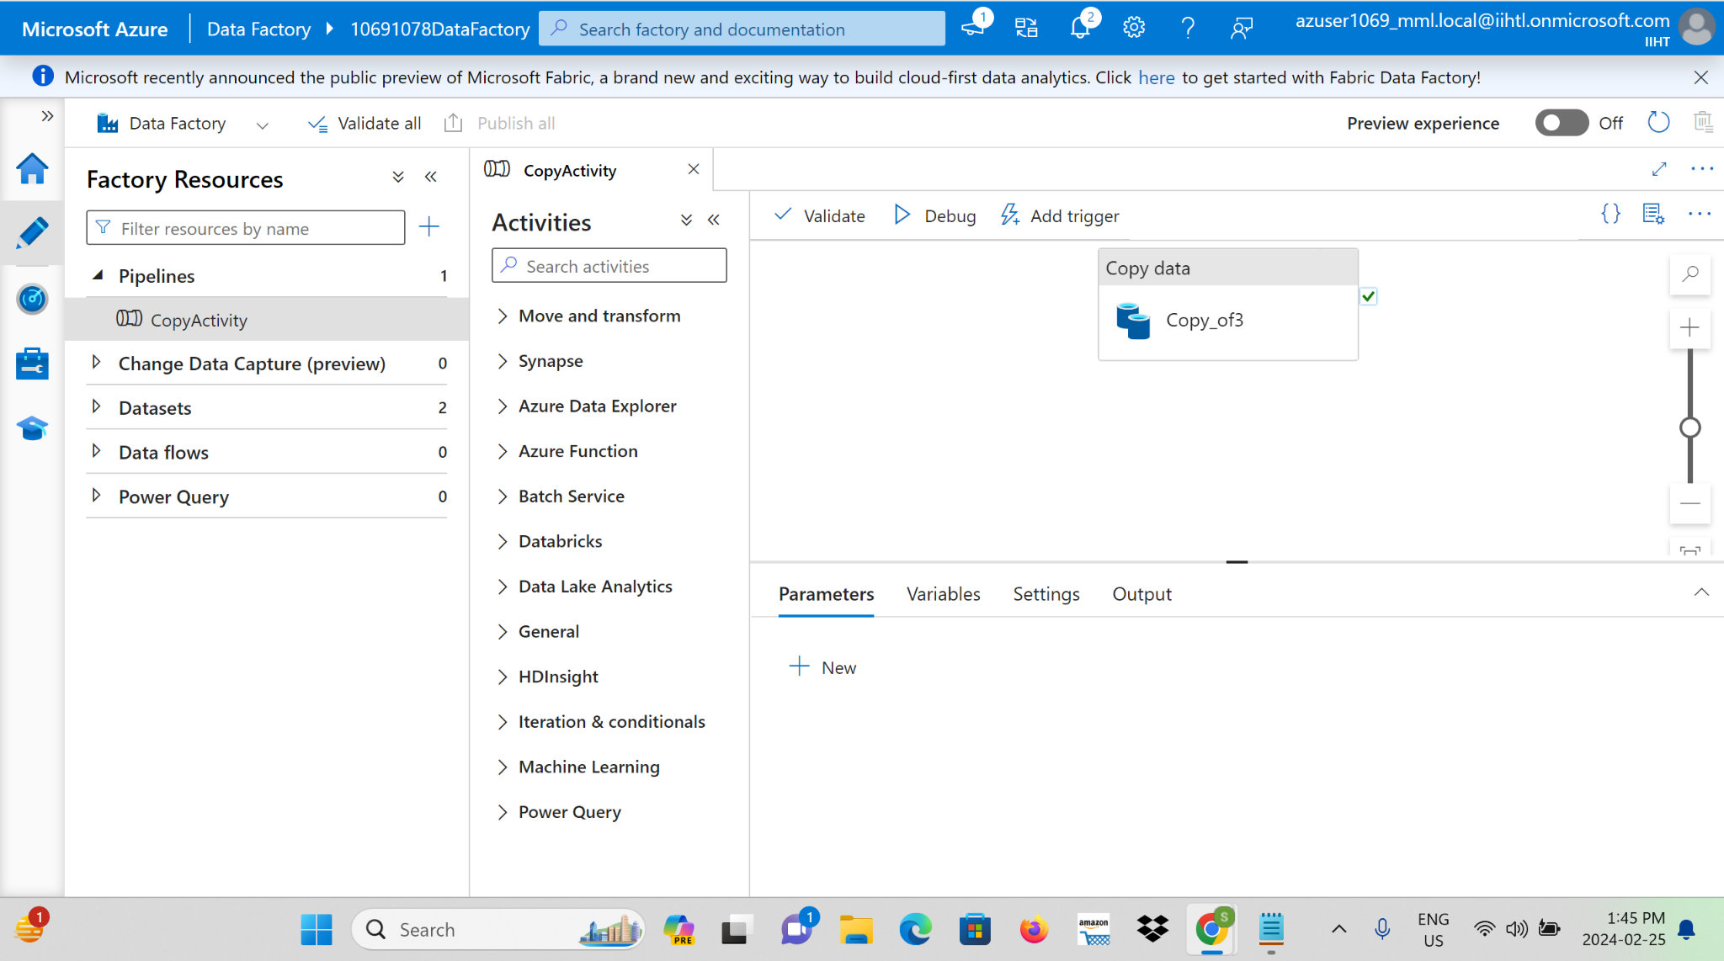

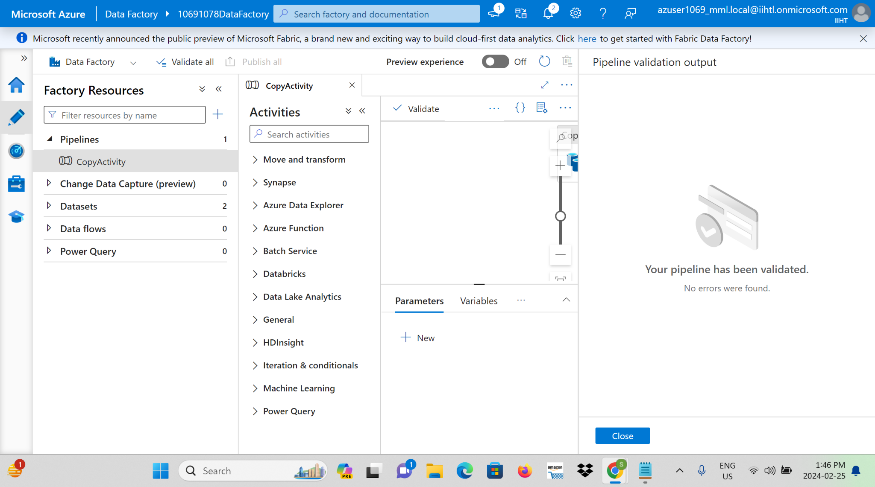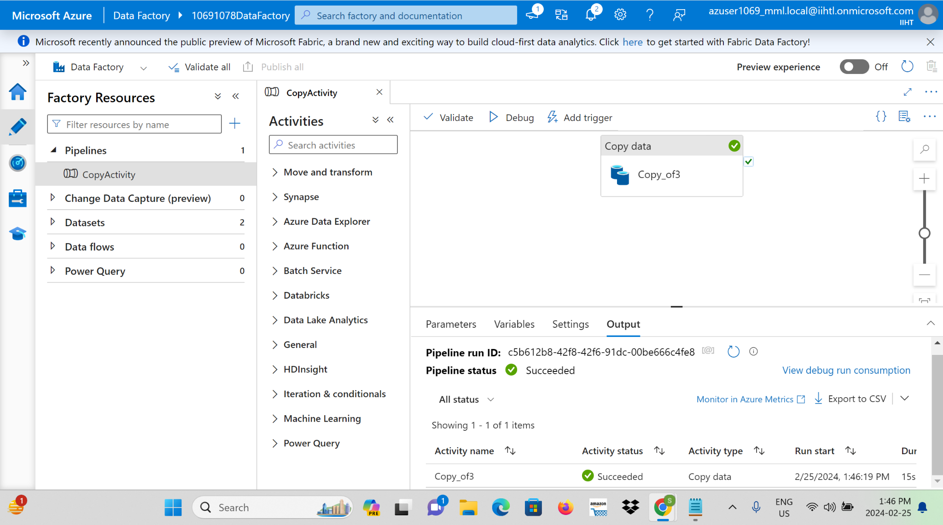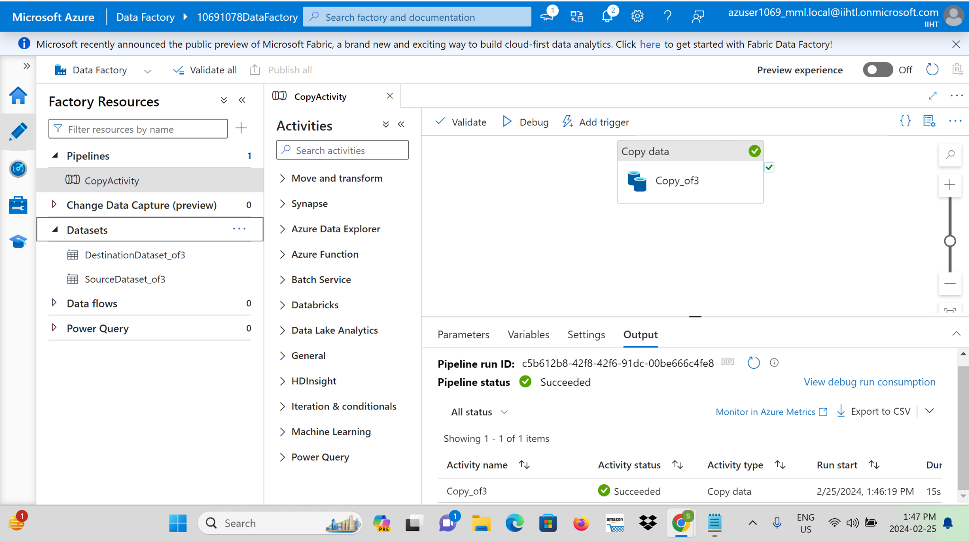

**CONCLUSION:**

This real-time data processing solution combines the strengths of Azure Data Factory and Azure Databricks, creating a dynamic and scalable architecture. It empowers organizations to derive actionable intelligence from streaming data sources in near-real-time, facilitating informed decision-making.